

Hypercar Executive Summary
HHHigigighhh---PPPeeerrrfffooorrrmmmaaannnccceee CCCaaarrr EEExxxeeecccuuutttiiivvveee SSSuuummmmmmaaarrryyy
AQOS PM

AQOS PM

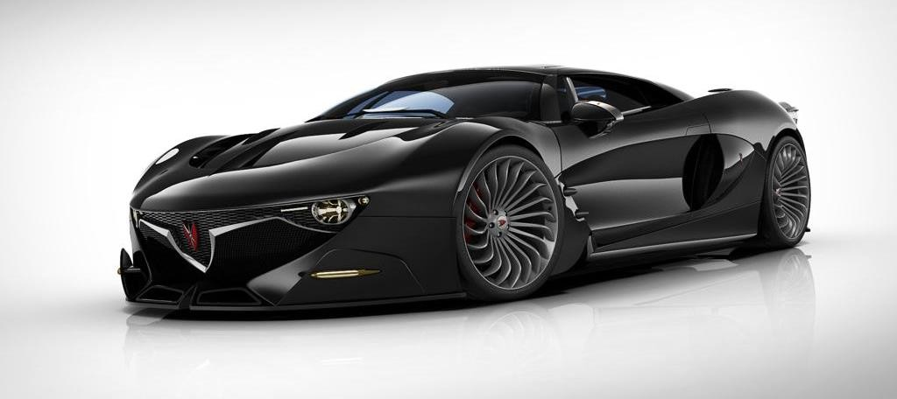COMPANY OVERVIEW

AQOS Technologies is the company engaged in design, research, and production of cars.

01 Introduction

The essence of creating
02

About Aqos
03
CEO

- Statement

Basic information about company

How AQOS Technologies
approaches to design

Meet our founder and CEO

What is basic idea of PM

- AQOS PM intro
- SWOT analysis AQOS PM
07
project

Sales and revenue
08
What are the key messages about AQOS PM

Where are we on the
market

Our predictions on
business

The expected potential net profit and new profit business

AQOS PM
09
exterior

AQOS PM
10
interior

Business overview
11

EQOSS
12
electromobility
Take a look at the outside

Take a look at the inside

Meet our core of the
business

AQOS Technologies sub-
project

Our plan and
13
team
Meet our plan and the
team of professionals

INTRODUCTION 01

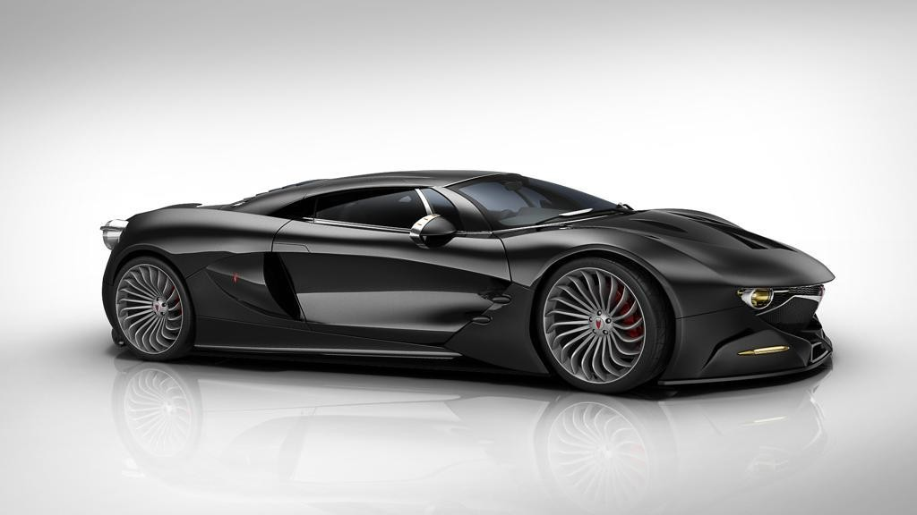AQOS Technologies was founded in Belgrade, Serbia, as a company
to be involved in international markets of high technology products.
AQOS Tec. was established to formalize years of design research, drawing on excellent knowledge of the tradition and philosophy of car construction, as well as great individual experiences, knowledge, and commitment. The company is the result of the work of a group of independent, experienced professionals from different fields, including design, engineering, technology, and architecture. The main occupation of the company is research in all aspects of the auto-industry, including the design of innovative car parts and the production of limited series of high-performance sports cars.
The team consists of established domestic and foreign experts from the UK, Germany, and Italy, supported by relevant scientific and research institutions and organizations, such as the Faculty of Technology and Metallurgy.

THE ESSENCE OF CREATING
02

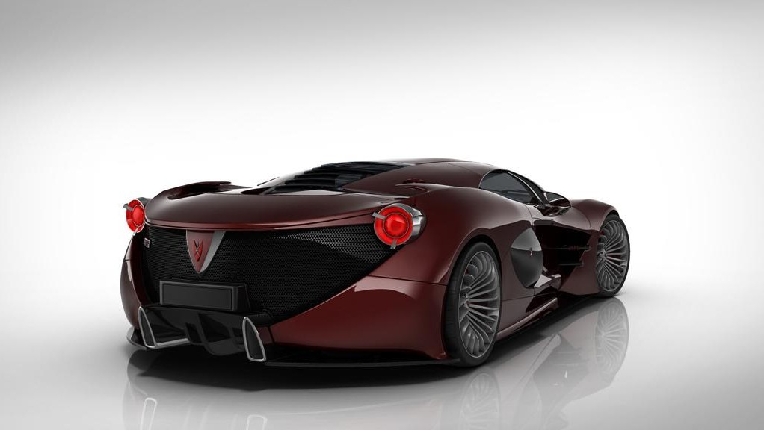
The essence of creating the new brand is based on the assumption that only a completely new concept and approach can meet the challenges of the new time. The input parameters for establishing and positioning the new ideology of building cars must be redefined.
AQOS Technologies approaches design as a means of articulating the constructional, mechanical, aerodynamical, ergonomic, technological, philosophical, and economic aspects of a car.
The AQOS program is a step forward towards the originality of design, as well as separating from the common imitation in the car industry, with the capability to respond to the competition. The AQOS program is based on conceptual solutions of already existing classes of cars and on forming new classes as an answer to the new market tendencies.
The AQOS Project is the car manifesto of the new business philosophy.



ABOUT AQOS CEO 03

The team is led by the chief designer, Mr Saša Milovančević, who has already made significant achievements in creating existing cars and has collaborated with the largest automakers worldwide.
Leader of the team graduated on University of Belgrade - Faculty of Architecture, Serbia, and on Polytechnic University of Turin, Italy.
Mr Saša Milovančević has collaborated with the biggest automakers worldwide such as: Mercedes-Benz, VW, TVR, Porsche, Daewoo, etc..
In 2001 he founded AQOS, a studio for construction, research, industrial and architectural design in Milan, Italy.
In 2012 he founded AQOS Technologies, the company engaged in
design, research and production of cars.

04

STATEMENT

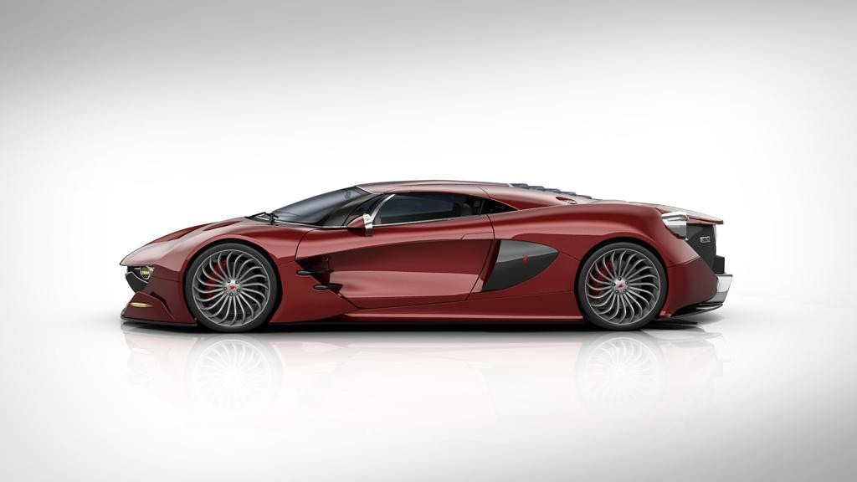Only talent allows us to be unique and to avoid “regular” situation in our work. What is required in the economy of the future is an “irregular” state.
What we need is an innovative business, different, unpredictable, full of surprises. It is the basic idea of AQOS PM. It is unique, provocative, and completely different in view of the contemporary car industry.

05

wAeQpreOseSnt PyoMu

DIFFERENT
AQOS PM was built as a polygon for the realization of sophisticated solutions which will create strong and authentic AQOS brand (trademark) whose identity should not be based on aggressive marketing campaign, but on itself.

UNPREDICTABLE
AQOS PM is a step forward towards originality of design as well as separation from the common imitation in the car industry, with the capability to respond to the competition.
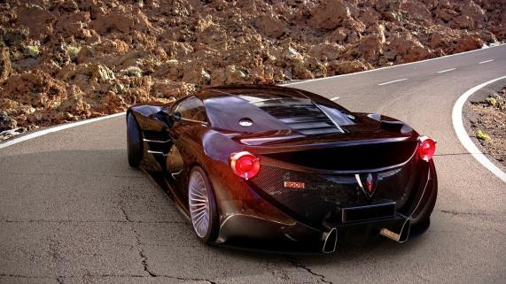AQOS program is based on conceptual solutions of already existing classes of cars and on forming new classes as an answer to the new market tendencies.

FULL OF SUPRISES
The AQOS PM is made to fundamentally shake the automotive industry. The fact that is made in Serbia makes it even more innovative, unique and intriguing.
AQOS Project is the car manifesto of the new business philosophy.

SWOT ANALYSIS 06

STRENGTHS
New vision and strategy Diversification of strong product Unique new product
Brilliant unchangeable

OPPORTUNITIES
Creating new trend in automotive business
High possible profitability and revenue

styling/designing

WEAKNESSES
New entrant in global market with
better features and design

THREATS

No brand history
No brand presence and reputation across globe
Time consuming process of building trust of investors and business partners Economic slowdown
Barriers of market entry Volatility in global car demand Increasing fuel price
Rising raw material prices
New emission standards

AQOS PM PROJECT 07
Our prediction is of the ability to produce and sell 1.000 units of high-performance vehicles, with a price range of €1.000.000 per unit.
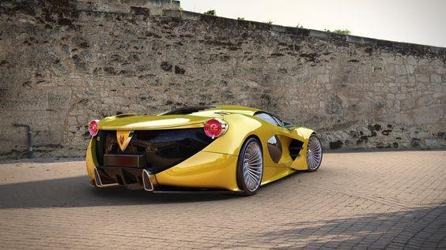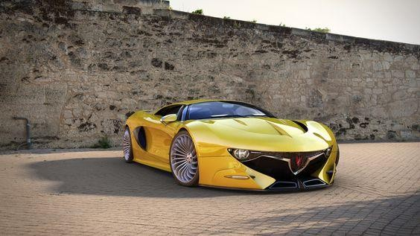We are even considering the number of 1.000 units as a conservative estimate, but it is insisted on because of the exclusivity of the vehicle, which will be confirmed by the ultimate design, engineering, and absolute uniqueness of each unit (there will be no two identical cars) as well as the highest final quality that should set new standards in this class of cars.
AQOS PM PROJECT 07

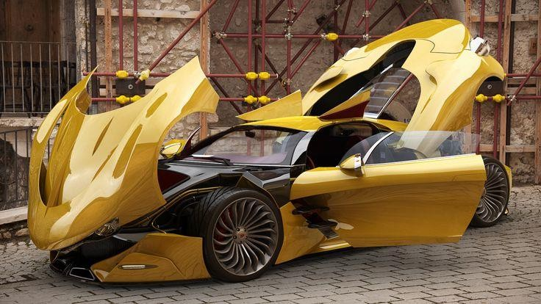
For the first and most important stage, approximately €15 million is needed to create a concept vehicle, make a brand book and do detailed analyses of all costs in order to define the steps necessary to implement such a complex project, based on which a marketing campaign could be activated, giving to the project additional access to the required capital.
In the process of project implementation, special engineering and production entities will be engaged, such as: RICARDO, ENVISAGE, ABT SportsLine, RENNtech, etc..

AQOS PM PROJECT 07
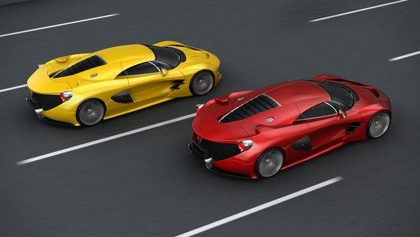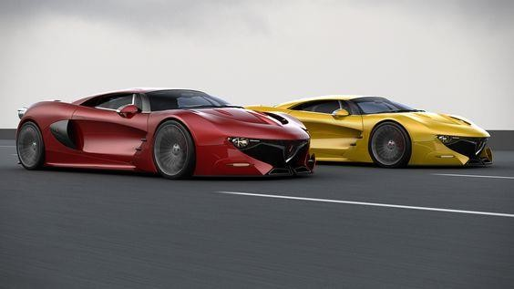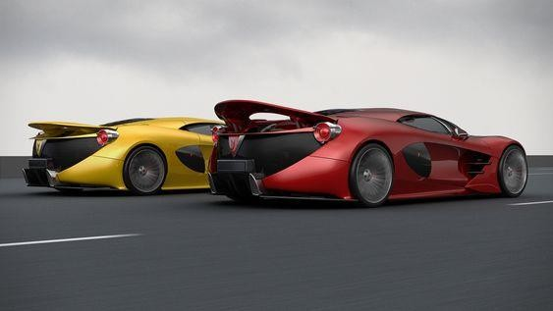The projected income of €1 billion in the period of 5 years, with the capital contribution in the project, amounting ~€170-200 milions, clearly confirms the economic concept of this project.
Funding requirements are:
- €80-90 mill (development and construction of mobile prototypes, testing, tooling, homologation, etc.)
- €30-40 mill (building a car assembly plant, procurement of equipment, etc.)
- €60-70 mill (start of production, row materials,
procurement of car components and systems, etc.)

Production financing is by using working capital and partial advance payment of the car at the time of booking.

SALES AND REVENUE PROJECTION 08

The expected potential net profit of about €550 million is imposed as a realistic and very conservative estimate.

The newly created brand itself is an ideal base for launching new profit business units such as the creation of a fashion line, inspired by the link between show business and automotive philosophy, accessories (watches, jewelry, Hi-Fi), speedboats and even yachts.
The assessment of these additional business activities requires additional analysis, that can be obtained in a
relatively short period of time.

We believe it is important to point out that in order to start the active process, the investment can be made in several stages that will be defined after a detailed analysis of the project.
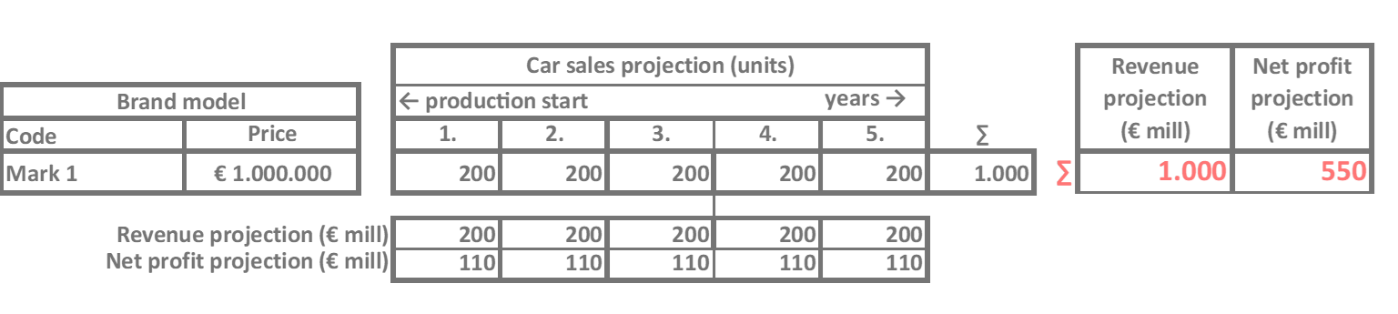

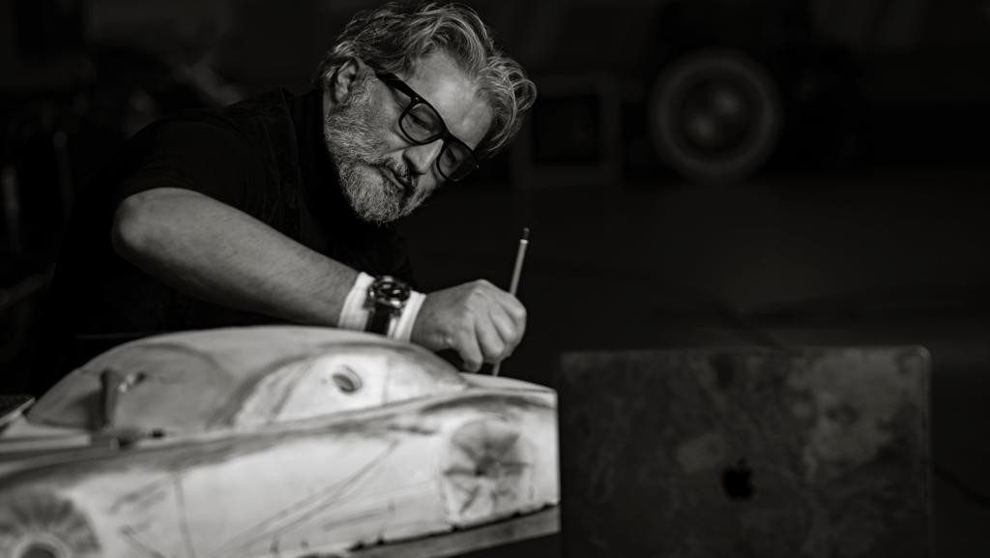

The birth of a new brand begins the moment you feel the power of dominance over a car, from which you are looking at the present moment from a historical distance, i.e., when a new logical algorithm is set that articulates all the manifesting questions related to the philosophy of car making and their technical realization. The meaning and the full effect of a new brand is only possible if the momentum is synchronized with understanding the needs of civilization. At that moment and in that case, we have the effect of the market void, which absorbs the new ideology of the new brand.

Saša Milovančević, CEO

AQOS PM EXTERIOR 09
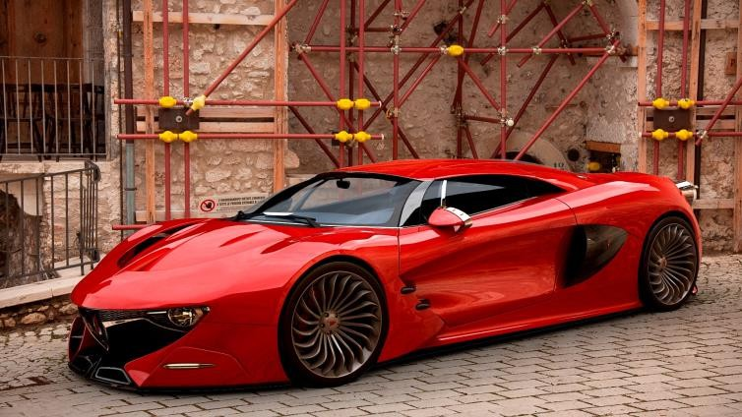
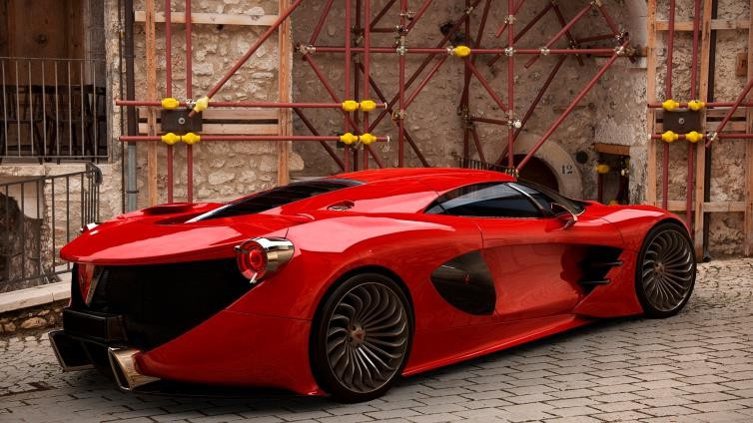
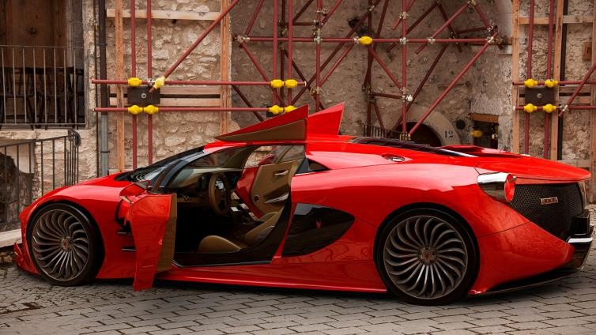
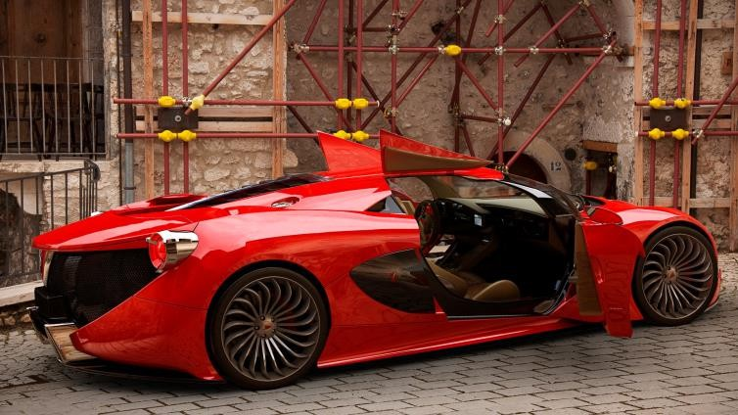

AQOS PM INTERIOR 10
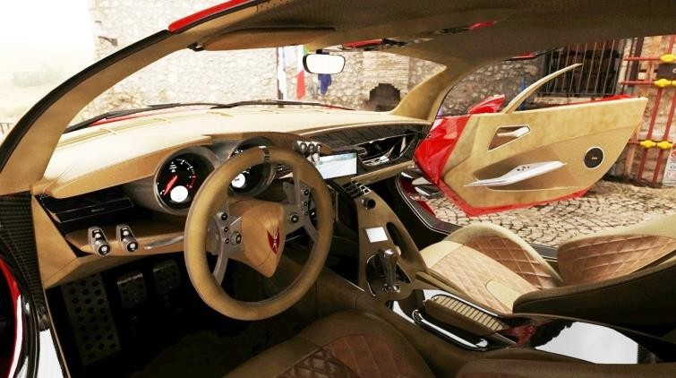
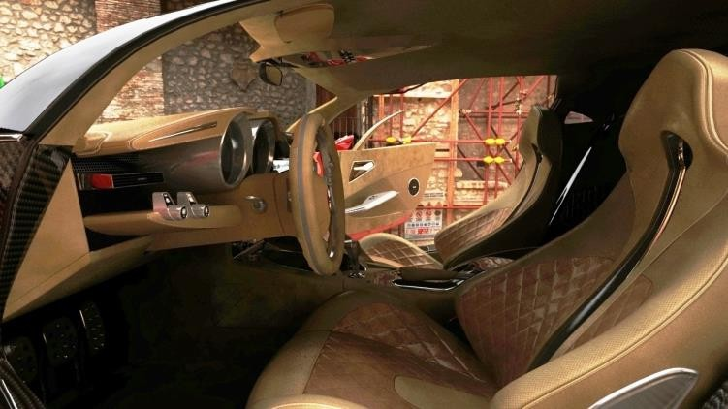
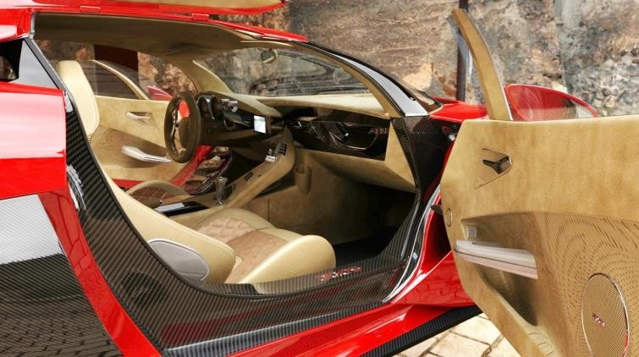
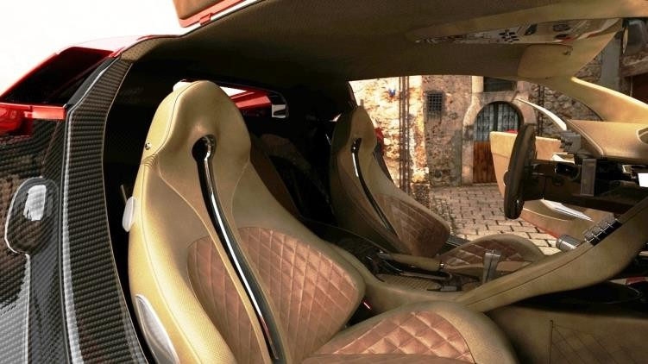

BUSINESS OVERVIEW - CORE

1111

VALUES DESIGN SUSTAINABILITY COMMUNITY
ENGAGEMENT

-Enabling consumer sustainable choices
-High-performance oriented
-Deeply rooted design heritage through backing from experience
-Differentiation through avant-garde design, driving experience and sustainable choices
-High tech minimalism that defines luxury for the sustainable age
-Designer-led leadership and product development focus
-Best-in-class sustainability ambition
-Planned introductions of sustainable materials
(e.g., natural fibers and recycled materials) throughout interiors as product portfolio matures
-Professionalized marketing approach and real time brand valuation
-Transparency

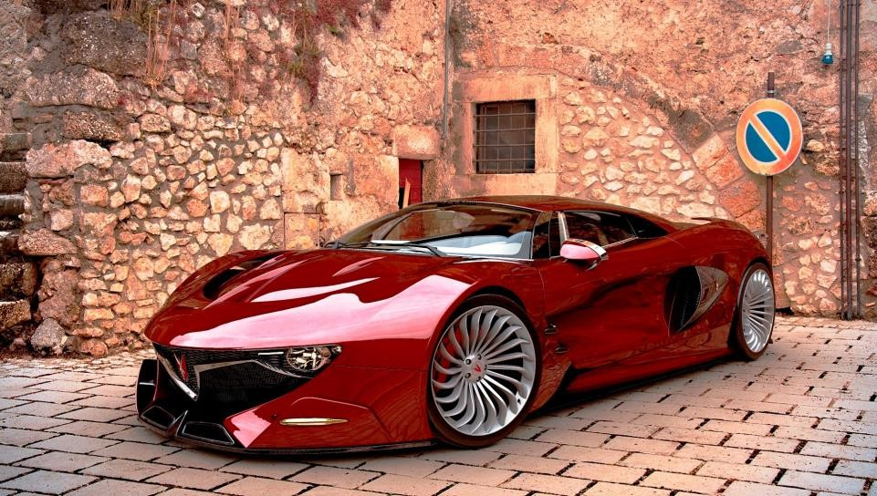
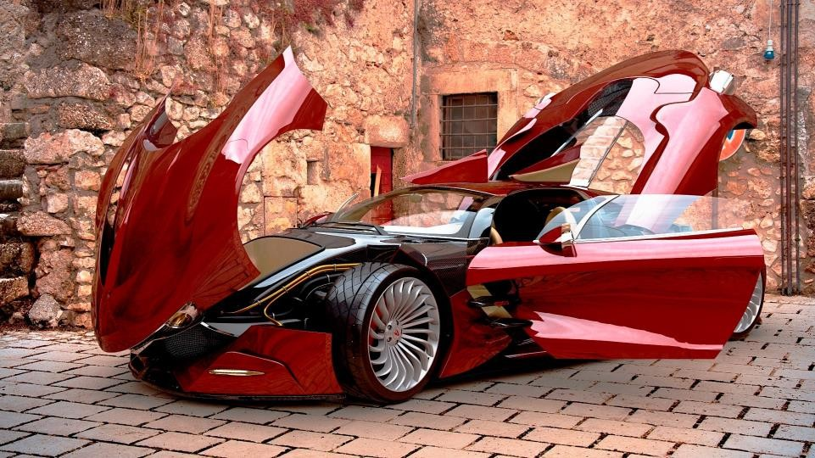
A Picture Is Worth a Thousand Words

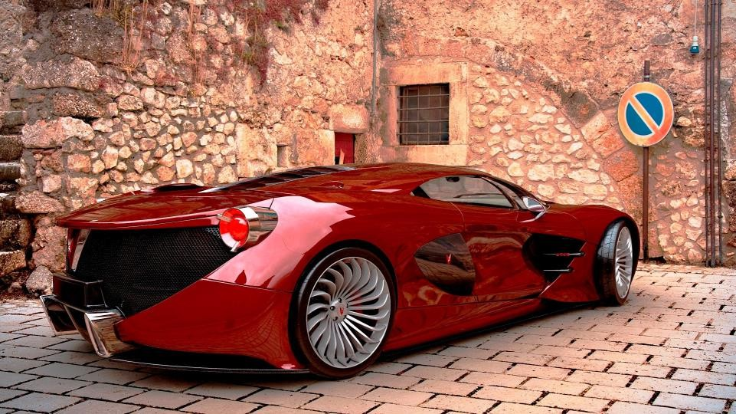
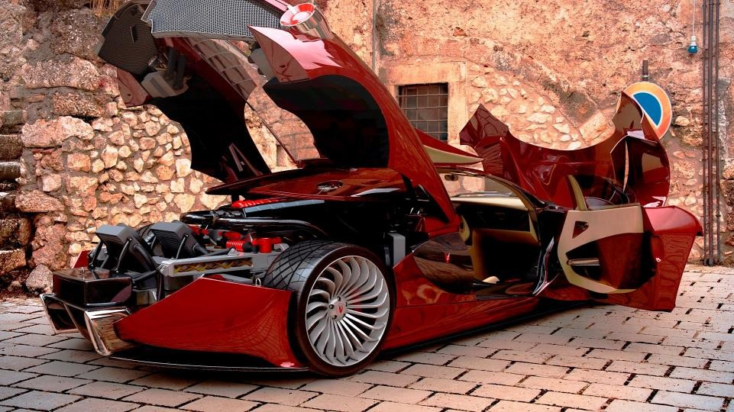
A Picture Is Worth a Thousand Words

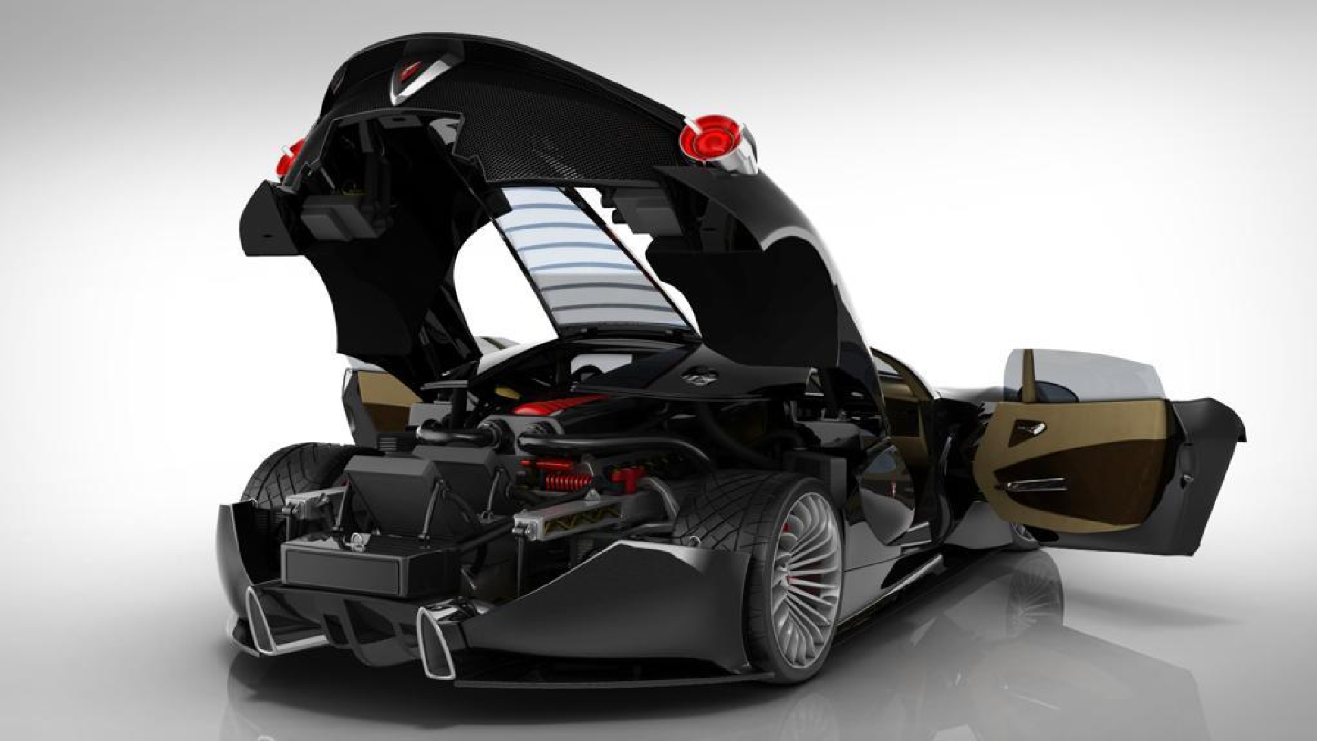

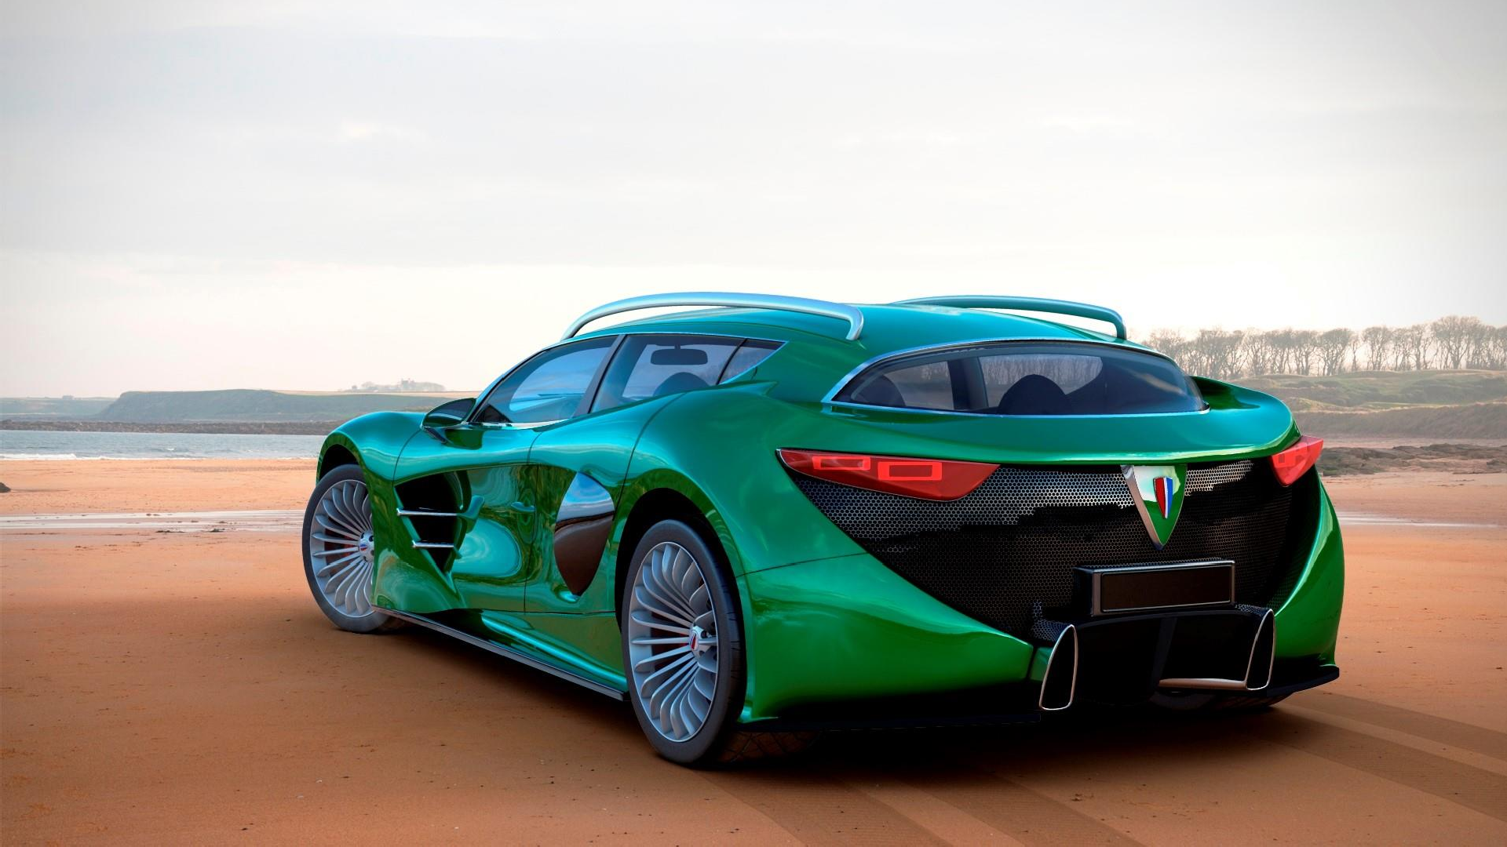AQOS ELECTROMOBILITY 12
Electromobility will be a central part of future powertrain design. The biggest challenge will be to identify the most promising technology. New vehicle and drive concepts are crucial elements for the automobile.

QUESTION

Why electric vehicle (versus the vehicle with internal
combustion engine)?

ANSWER

Increased torque. Increased efficiency. Quietest. Greater simplicity.
Greater reliability. Uses regenerative brake. Do not pollute the environment. Requires less maintenance. Do not consume fuel. Can be used for energy storage. Flexibility in relation to power generating sources. More power per weight unit or volume unit.

EQOSS ELECTROMOBILITY 12
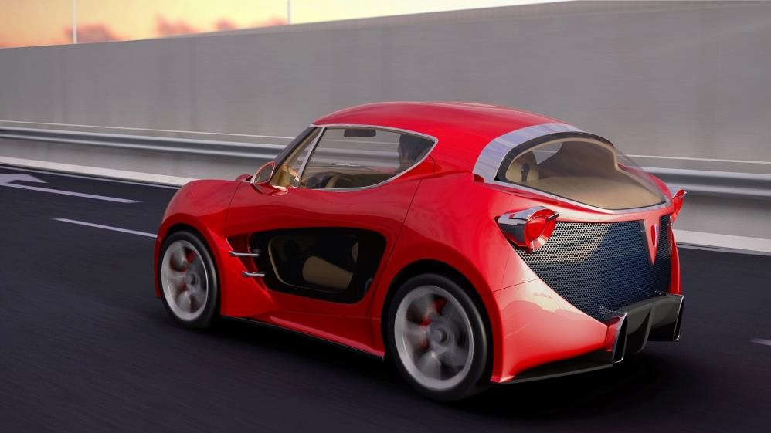
Electric vehicles can free towns of pollutants, fine dust and noise to raise the quality of life.
The activities in the electric vehicle market created opportunities for investors and manufacturers interested in sustainable transportation. The recent years provided manufacturers as well as consumers with ample thrust to accelerate the transition towards electric vehicles. There is the big potential capable to cause profound changes in the global auto industry over the next five to 10 years.


EQOSS ELECTROMOBILITY 12
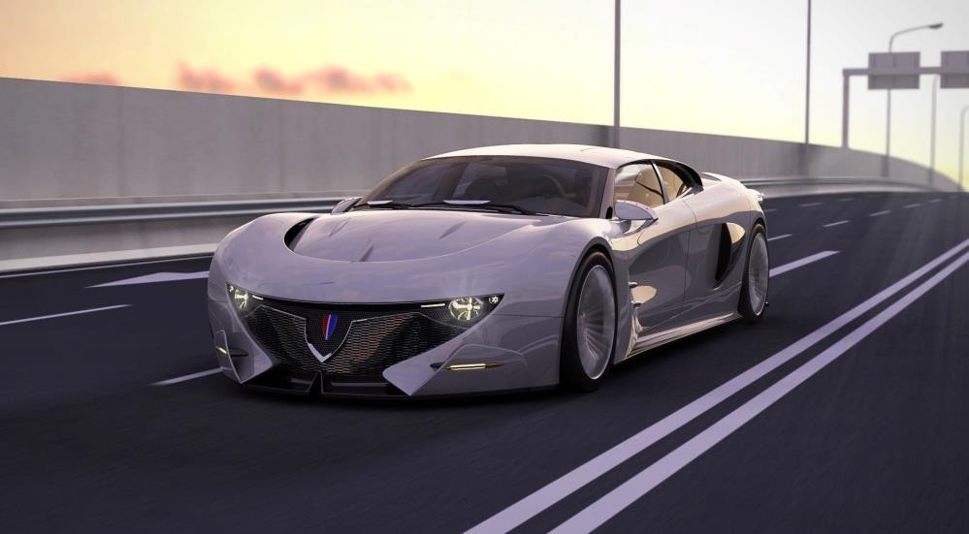
EQOSS Electric Car Brand Project will play a pivotal role in defining the future shape of mobility. Value and power of the EQOSS conceptive solutions will be materialized by precise engineering, tested by exact scientific methods and led by proper projection and vision.
This AQOS Technologies sub-project includes innovation in the field of new structural composite materials based on nano-technologies, i.e., development and promotion of innovative car construction structure contributing to higher safety.

AQOS ELECTROMOBILITY 12

Absolute innovative design and some applied innovative technological solutions will be the key advantage EQOSS electric cars over competition. Innovative design of EQOSS electric cars will cause very positive reaction (feedback) of the global market and attract the customers from competitors.
AQOS Technologies has also several more key advantages over present automotive players:
- Can concentrate 100% of resources on electric vehicles and on the new technological challenges
- No legacy exposure to the diminishing incumbent technology
- Can attract talent to a smaller organization, which prioritizes advanced technology
- Can operate without the added costs sometimes associated with organized labor that larger
manufacturers must contend with
- Captures government(s) interest in employment by creating blue-collar.

AQOS ELECTROMOBILITY 12

EQnOabSlS Electro Car Brsatnd Project final aim is to have profitable production and to deliver high-quality, innovative and desirable product.
The greatest potential of EQOSS Electro Car Brand Project is a remarkable ratio between possible profit and investment.
Forming the final retail price of the cars will be the result of a defined technological process of production of cars and all the specifics of this EQOSS Electro Car Brand Project.

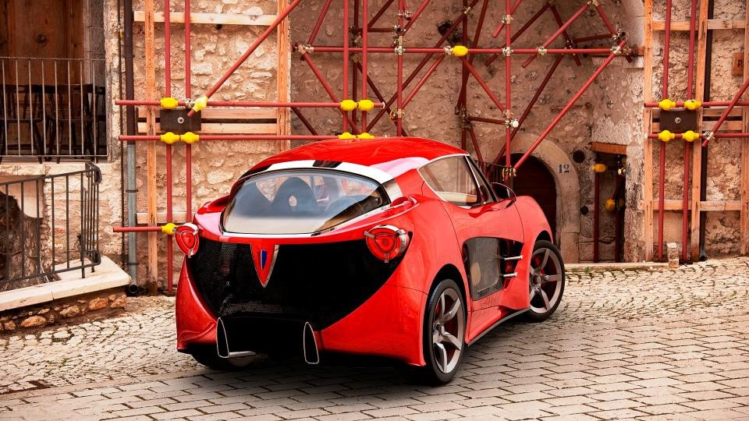
AQOS PM Supermini

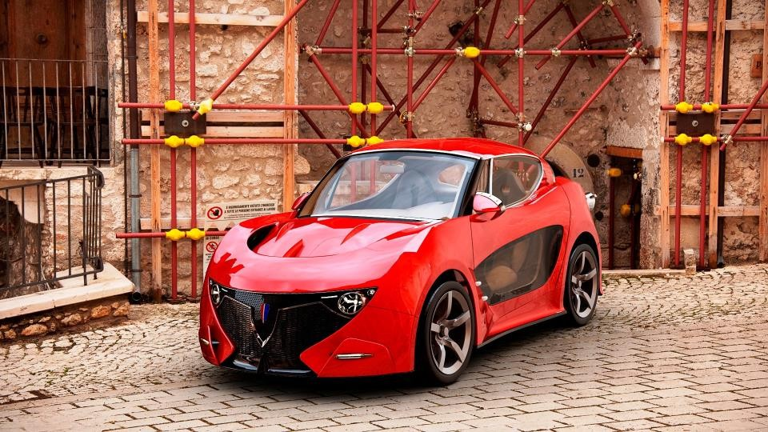

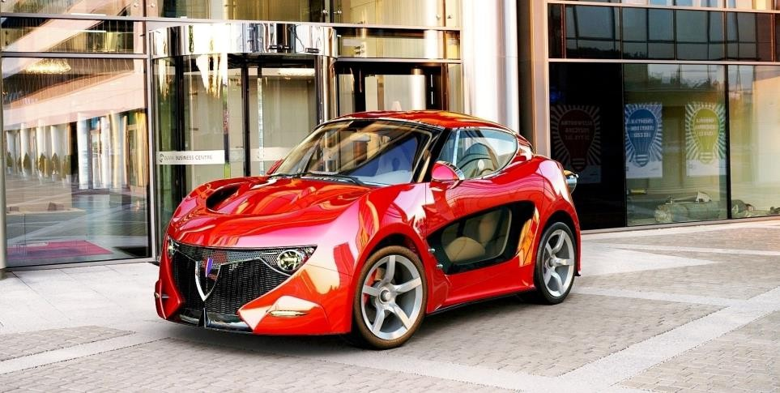
AQOS PM Supermini

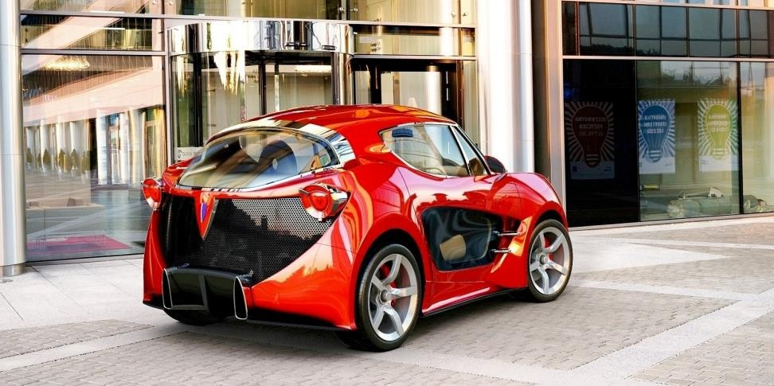

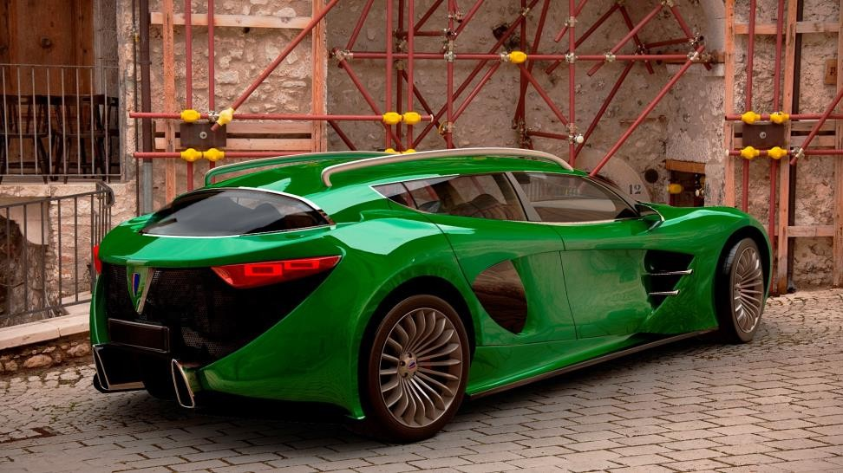
AQOS PM Crossover

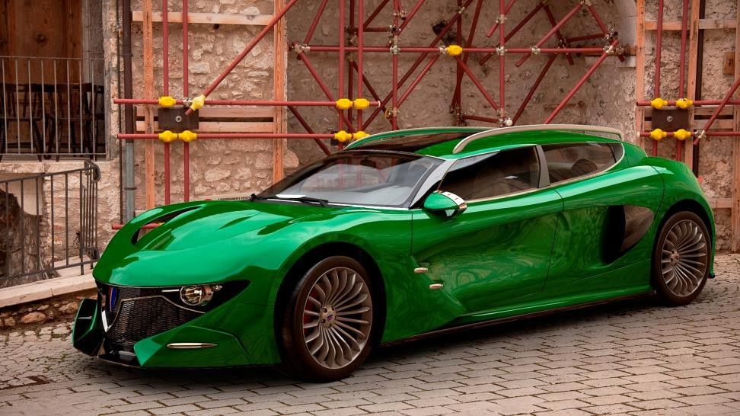


AQOS PM Crossover



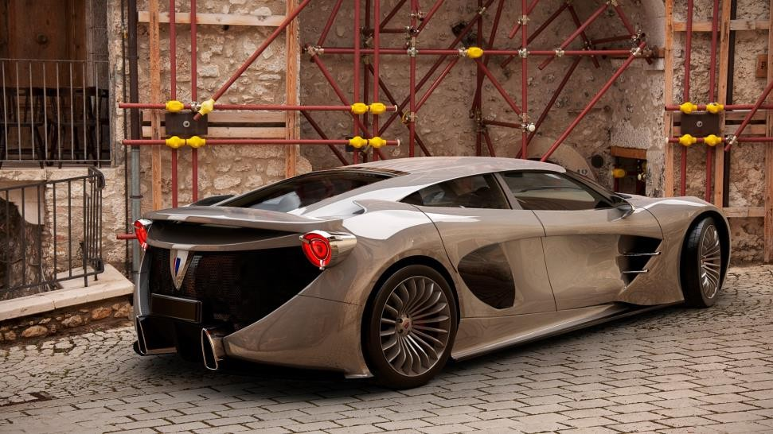
AQOS PM QPorte

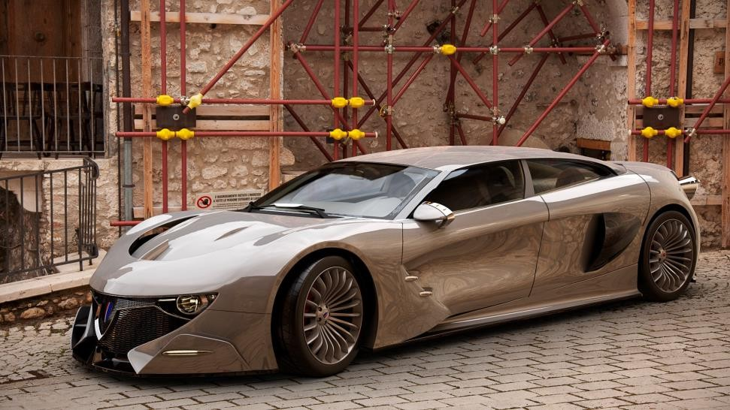

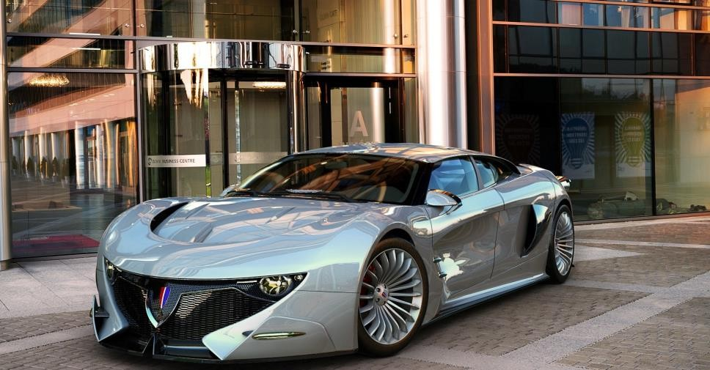
AQOS PM QPorte

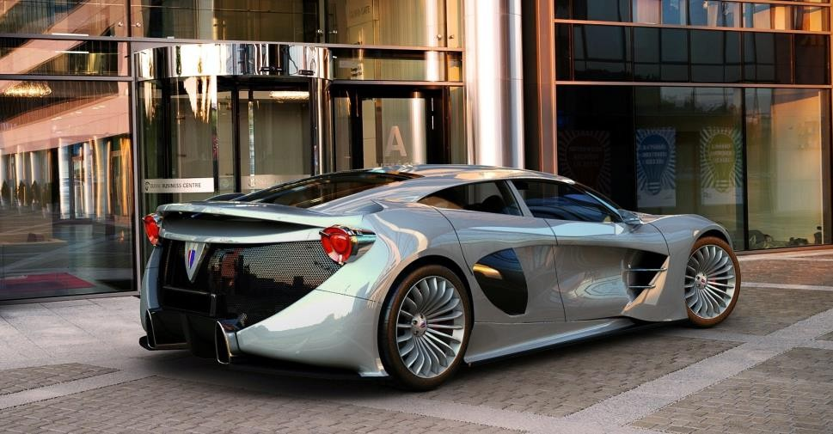

All additional information regarding the electromobility program
is available upon request.

OUR PLAN 13

Driveble concept vehicle
2024

Worldwide premiere
2025

G2M
Stock Market Opening of reservations
2025/...

OUR TEAM 13

Jenna Doe



Saša Milovančević
Founder - CEO & Chief
Designer

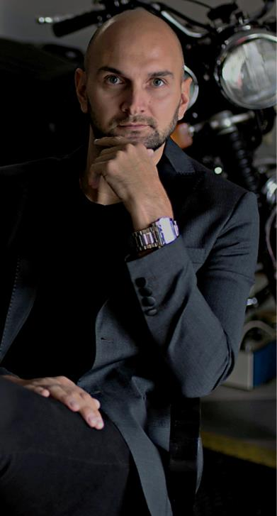

Marko Cvetković
Marketing

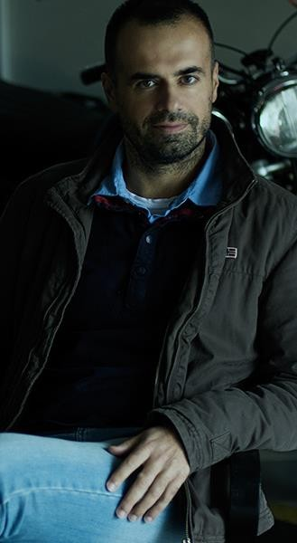

dr Igor Balać
Structural Engineering



dr Nebojša Kolarić
Strategy & Organization

OUR TEAM 13

Jenna Doe



dr Časlav Mitrović
Aerodinamics

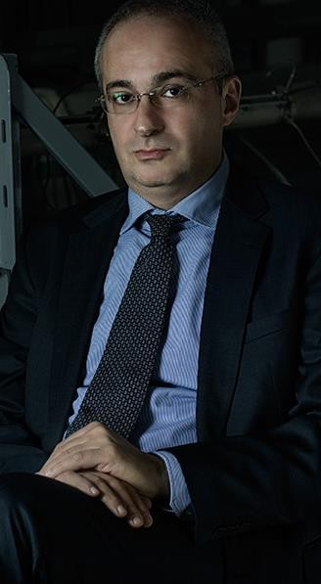

dr Petar Uskoković
Research and Advanced Engineering



Dragoljub Pavlović
Mechanical Engineering



Predrag Obradović
Product Development

OUR TEAM 13



M Sc Svetlana

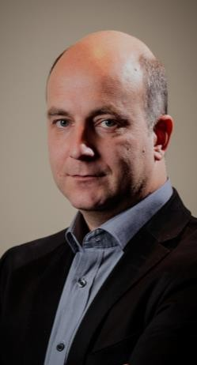
Čedomir

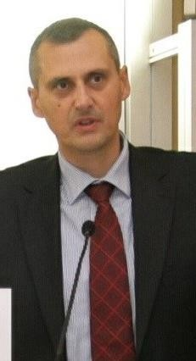

Prof. Dr. Aleksandar



Marko

Maksović
Business
Operations

Duboka
Chief Product Officer

Predrag Mitrović
Head of finance

Djoković
Head of car software

Santrač
Mechanical Engineering

Hypercar
project
developement

AQOS PM RACING CAR
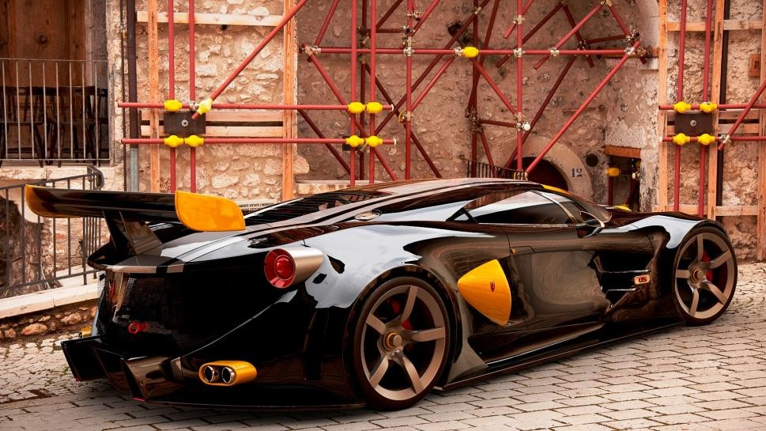
bonus preview

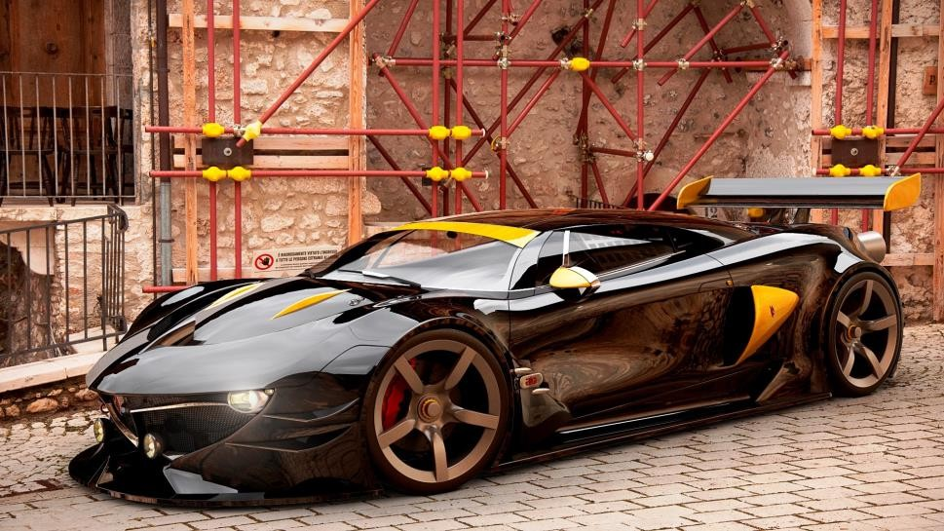

AQOS PM ACCESSORIES

bonus preview



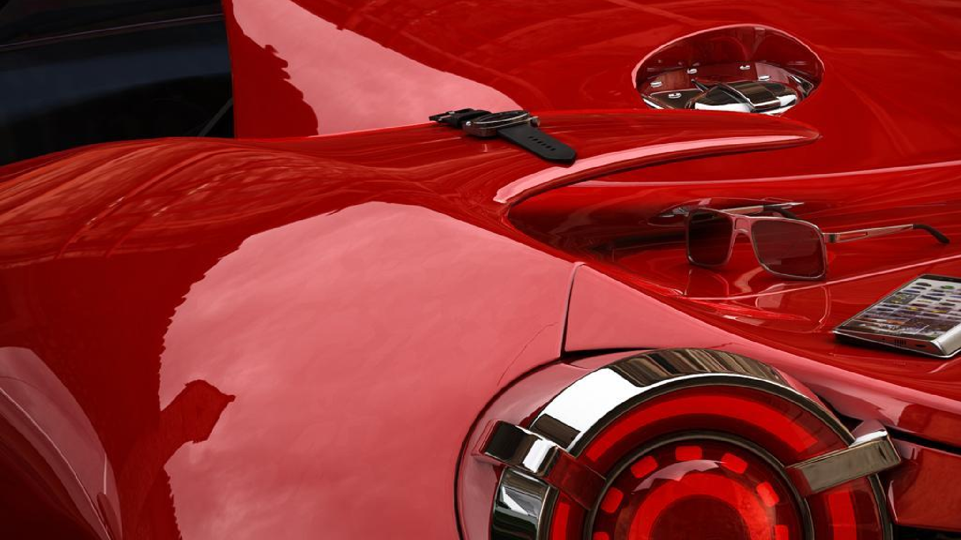

The object of desire called "the car" has converted the world economy to auto-centric in the last hundred years. Overproduction caused an overconfidence effect on the car manufacturers pleased with their mass production cars and therefore opened space for new brand positioning and new players.



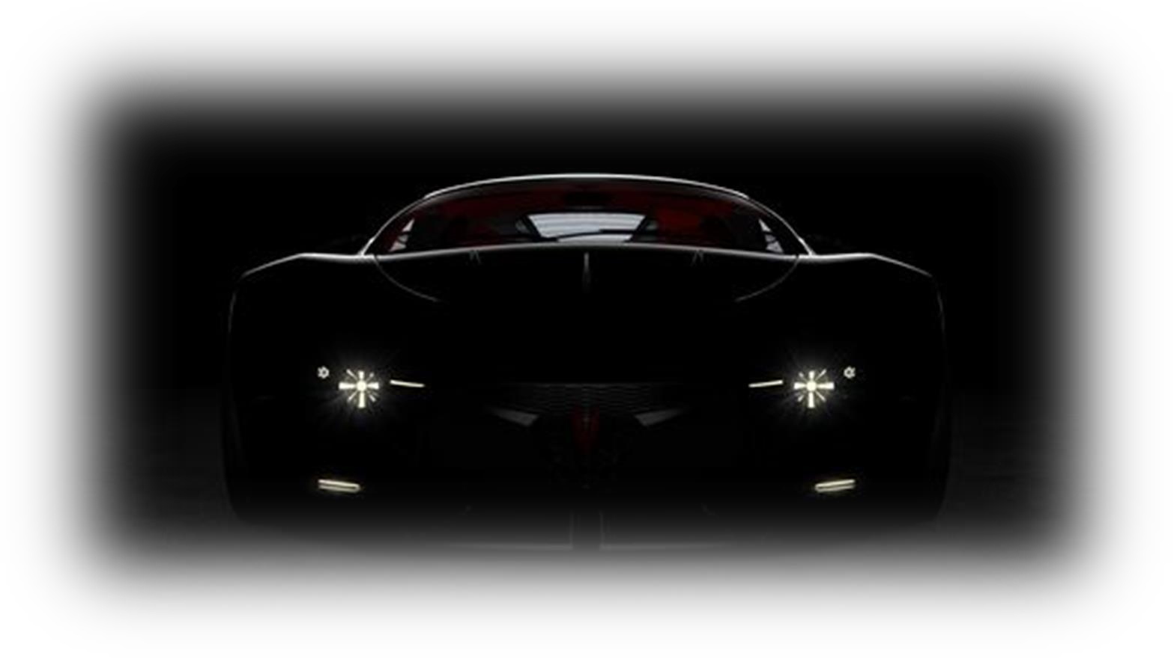Thank You
Aqos Technologies
Belgrade, Serbia marko.cvetkovic@aqos.co.uk
+381607150150
www.aqos.co.uk

