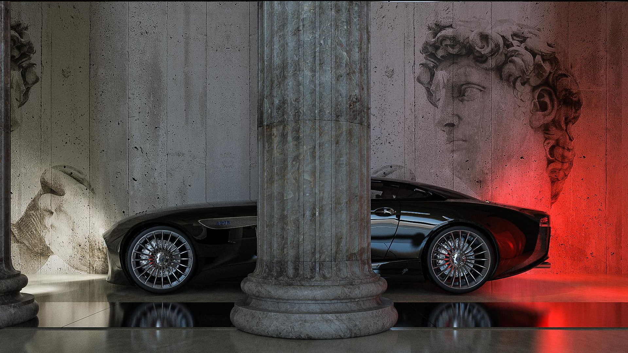

MONAQOS
AQOS Techonologies

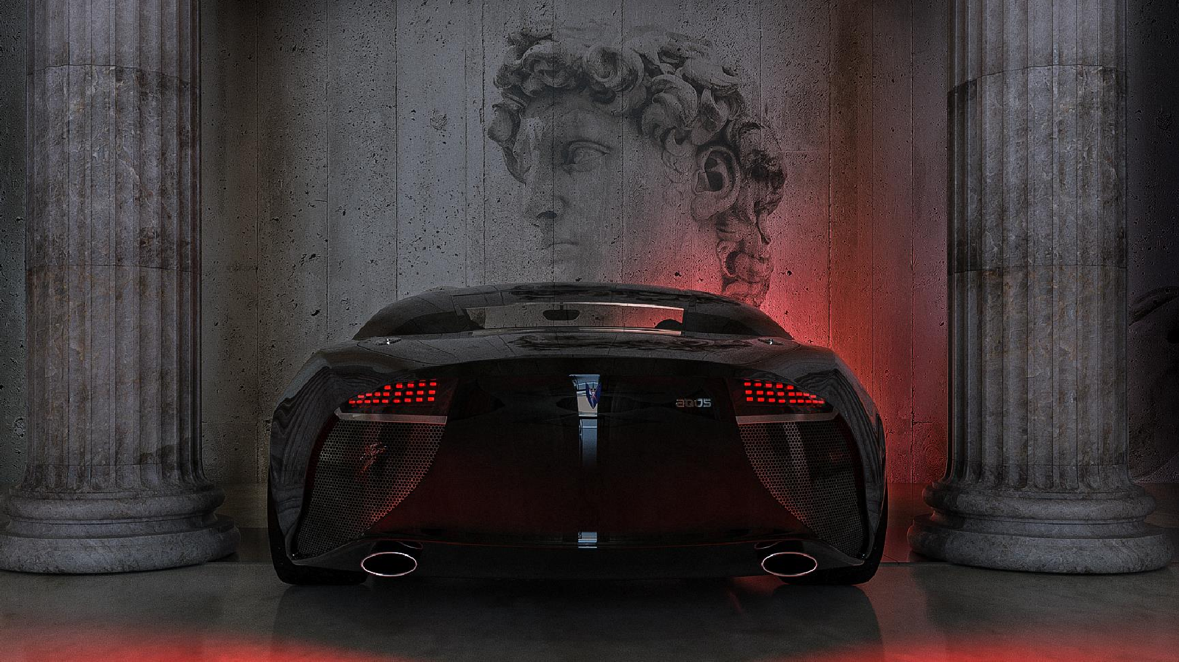

COMPANY OVERVIEW
AQOS Technologies is the company engaged in design, research, and production of cars.

01 Introduction

The essence of creating
02

About Aqos
03
CEO

Aqos MONAQOS
04

Basic information about company

How AQOS Technologies
approaches to design

Meet our founder and CEO

Meet our exlusive line

- AQOS Fiore GTS We present you Fiore

- Statement

- AQOS Dina Two models
08
idea

About our vision

We present you Dina

About limited edition models

AQOS
09
MONAQOS DNA The sensation of touch

- SWOT Analysis

- Benchmark

Sales and
12
Revenue

Business overview
13

Take a look at the inside

Our steps in project

The expected potential
net profit

Meet our core of the business

INTRODUCTION 01

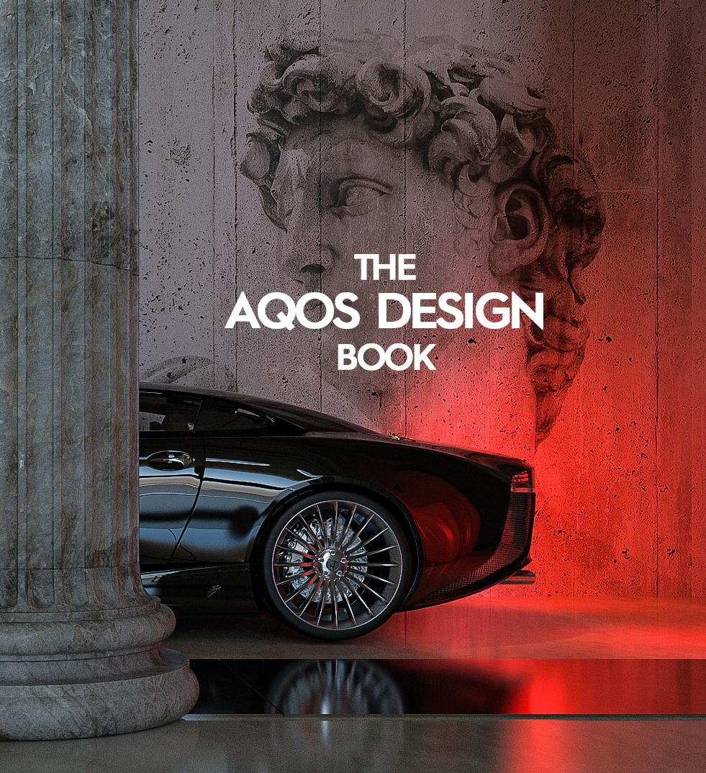
AQOS Technologies was founded in Belgrade, Serbia, as a company
to be involved in international markets of high technology products.
AQOS Techonolgies was established to formalize years of design research, drawing on excellent knowledge of the tradition and philosophy of car construction, as well as great individual experiences, knowledge, and commitment. The company is the result of the work of a group of independent, experienced professionals from different fields, including design, engineering, technology, and architecture. The main occupation of the company is research in all aspects of the auto-industry, including the design of innovative car parts and the production of limited series of high-performance sports cars.
The team consists of established domestic and foreign experts from the UK, Germany, and Italy, supported by relevant scientific and research institutions and organizations, such as the Faculty of Technology and Metallurgy at the University of Belgrade.

THE ESSENCE OF CREATING
02

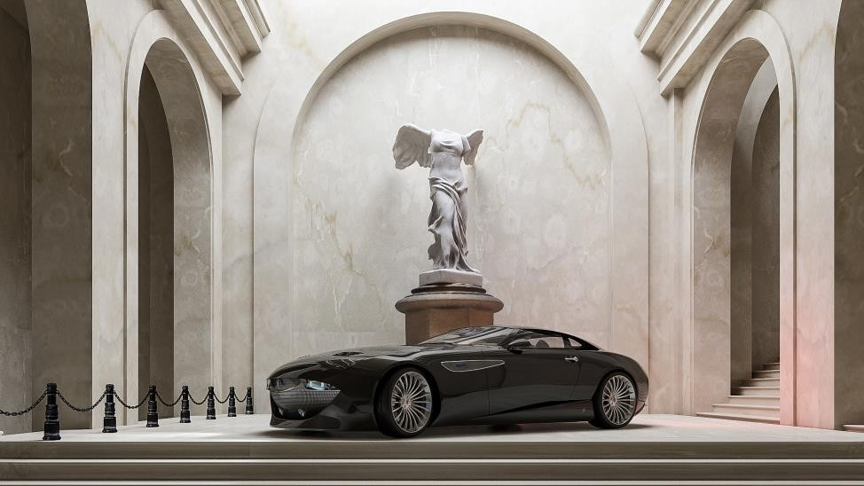
The essence of creating the new brand is based on the assumption that only a completely new concept and approach can meet the challenges of the new time. The input parameters for establishing and positioning the new ideology of building cars must be redefined.
AQOS Technologies approaches design as a means of articulating the constructional, mechanical, aerodynamical, ergonomic, technological, philosophical, and economic aspects of a car.
The AQOS program is a step forward towards the originality of design, as well as separating from the common imitation in the car industry, with the capability to respond to the competition. The AQOS program is based on conceptual solutions of already existing classes of cars and on forming new classes as an answer to the new market tendencies.



The AQOS Project is the car manifesto of the new business philosophy.



ABOUT AQOS CEO 03

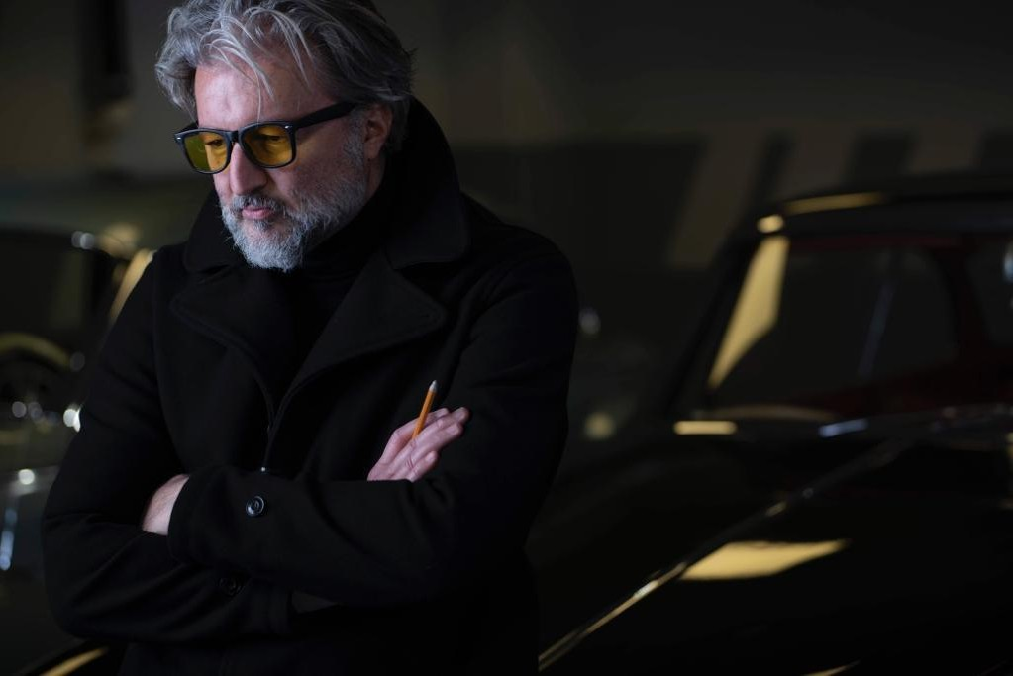

The team is led by the chief designer, Mr Saša Milovančević, who has already made significant achievements in creating existing cars and has collaborated with the largest automakers worldwide.
Leader of the team graduated on University of Belgrade - Faculty of Architecture, Serbia, and on Polytechnic University of Turin, Italy.
Mr Saša Milovančević has collaborated with the biggest automakers worldwide such as: Mercedes-Benz, VW, TVR, Porsche, Daewoo, etc..
In 2001 he founded AQOS, a studio for construction, research, industrial and architectural design in Milan, Italy.
In 2012 he founded AQOS Technologies, the company engaged in
design, research and production of cars.

AQOS MONAQOS PROJECT 04

AQOS project was created from the beginning of this century with the aim of retaining and enhancing the grandeur and phenomenon of the idea of free movement (car), and in this case that movement is still more an act of freedom, philosophy and above all aesthetics as a "desired" form of existence, because beauty is above all an expression of intrinsic inner content.
Guided with such a goal, we have created a brand ideology, which has just found its possible origin and understanding (by combination of incredible coincidences) in communication with the Passion Sea organization.
The consequence of this relationship is reflected precisely in the fact that aesthetic, ideology and ecology in this case have been liberated from the newly created patina of consciousness of this time, which made these extraordinary disciplines as consumer goods and thus devalued them to the point of nonsense.
Hence our suggestion that the fusion of 2 entities such as AQOS and the Principality of Monaco in the newly created logical formation be called MONAQOS as the super exclusive line of AQOS cars.

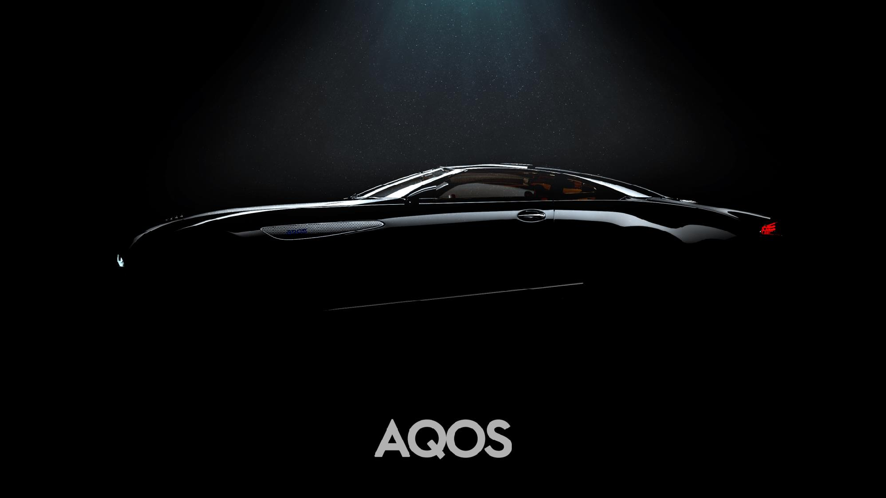

05

we present you
AQOS FIORE GTS

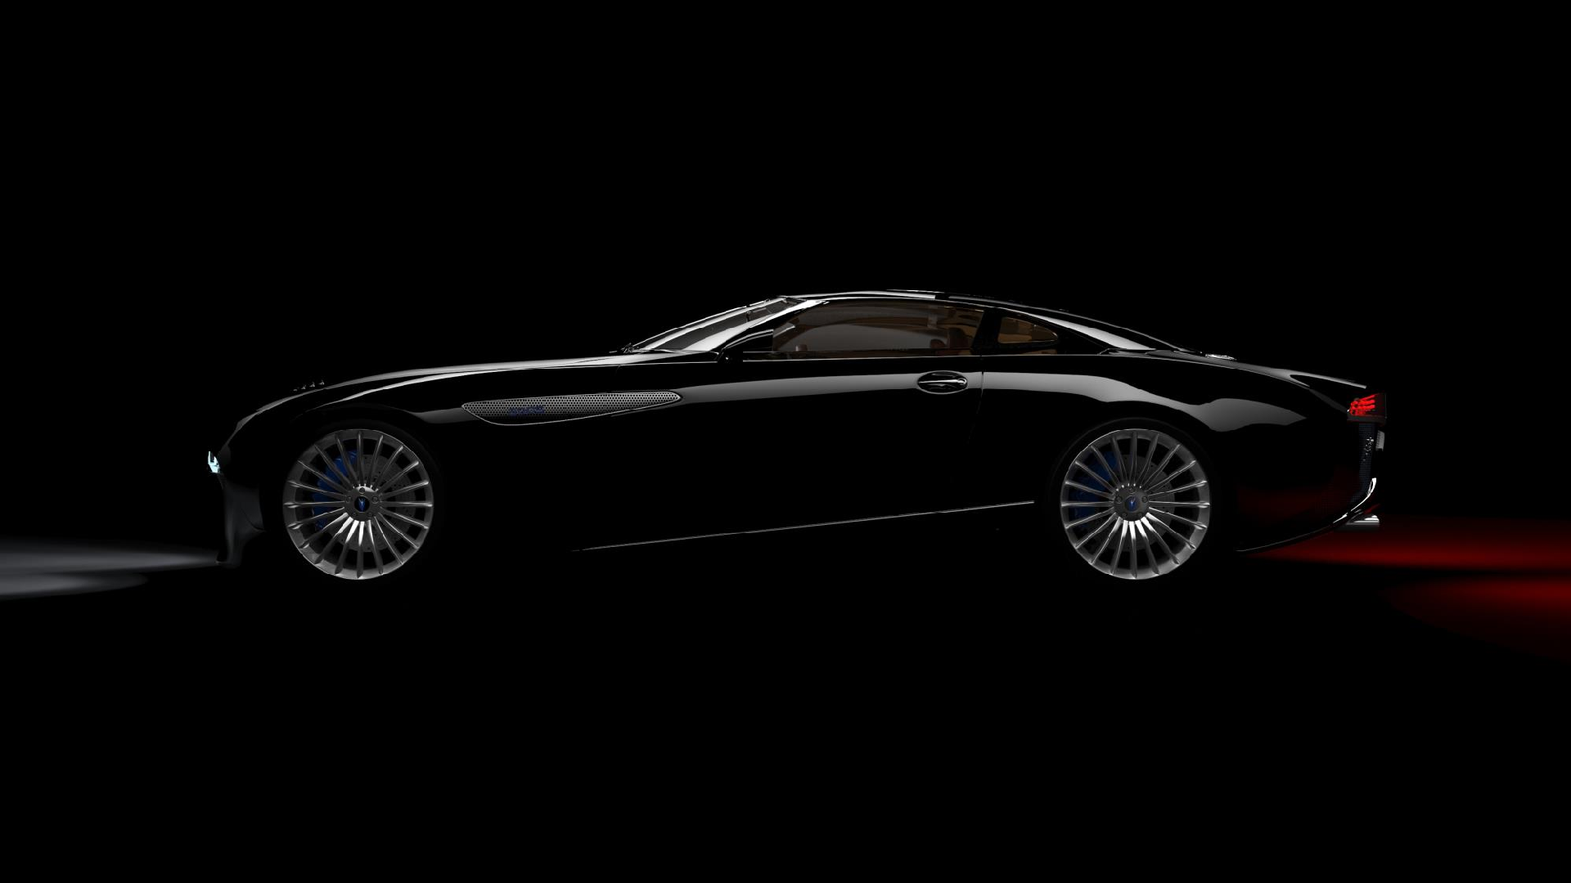


AQOS FIORE GTS

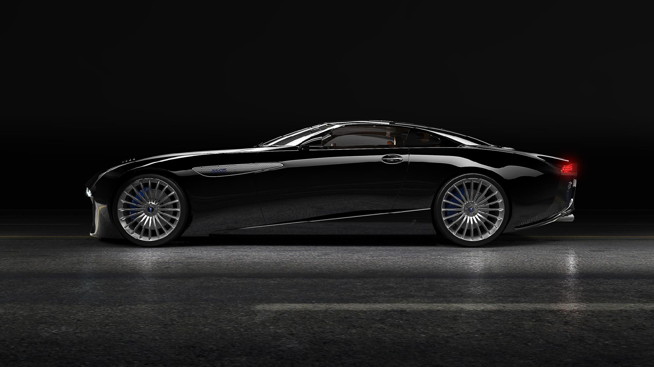

AQOS FIORE GTS

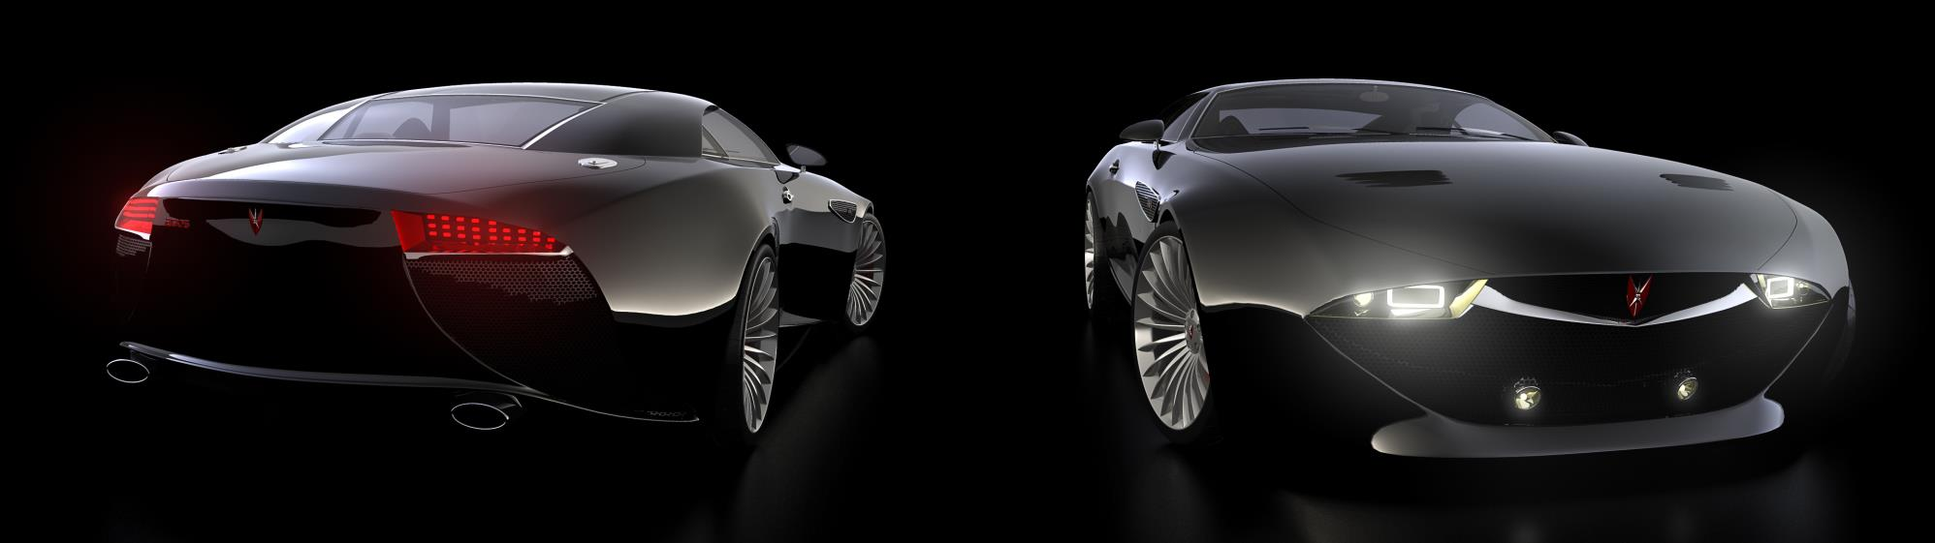


06

STATEMENT


Only talent allows us to be unique and to avoid “regular” situation in our work. What is required in the economy of the future is an “irregular” state.
What we need is an innovative business, different, unpredictable, full of surprises. It is the basic idea of AQOS MONAQOS line. It is unique, provocative, and completely different in view of the contemporary car industry.

DIFFERENT
AQOS MONAQOS was built as a polygon for the realization of sophisticated solutions which will create strong and authentic AQOS brand (trademark) whose identity should not be based on aggressive marketing campaign, but on itself.

UNPREDICTABLE
AQOS MONAQOS is a step forward towards originality of design as well as separation from the common imitation in the car industry, with the capability to respond to the competition.

AQOS program is based on exlusive solutions of already existing classes of cars and on forming new classes as an answer to the new market tendencies.

FULL OF SUPRISES
The AQOS MONAQOS is made to fundamentally shake the automotive industry. The fact that is made in Serbia makes it even more innovative, unique and intriguing.
AQOS Project is the car manifesto of the new business philosophy.

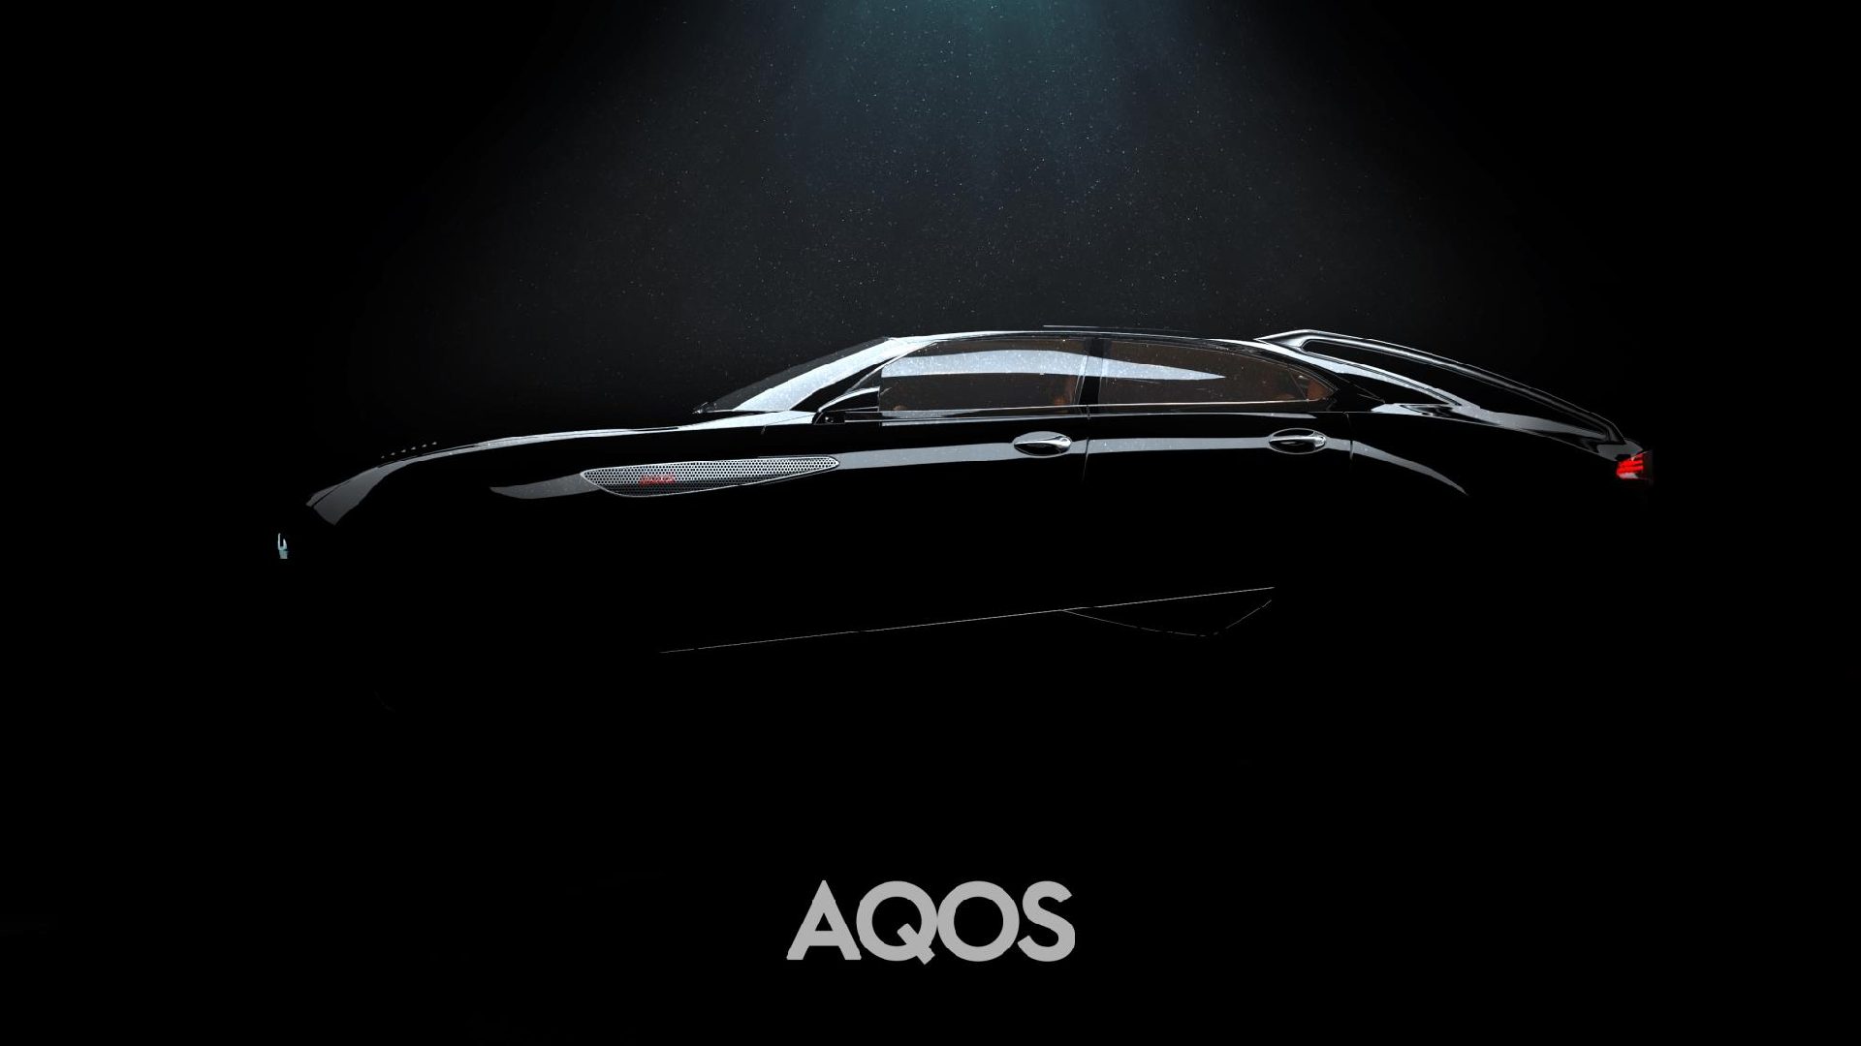
07

we present you
AQOS DINA

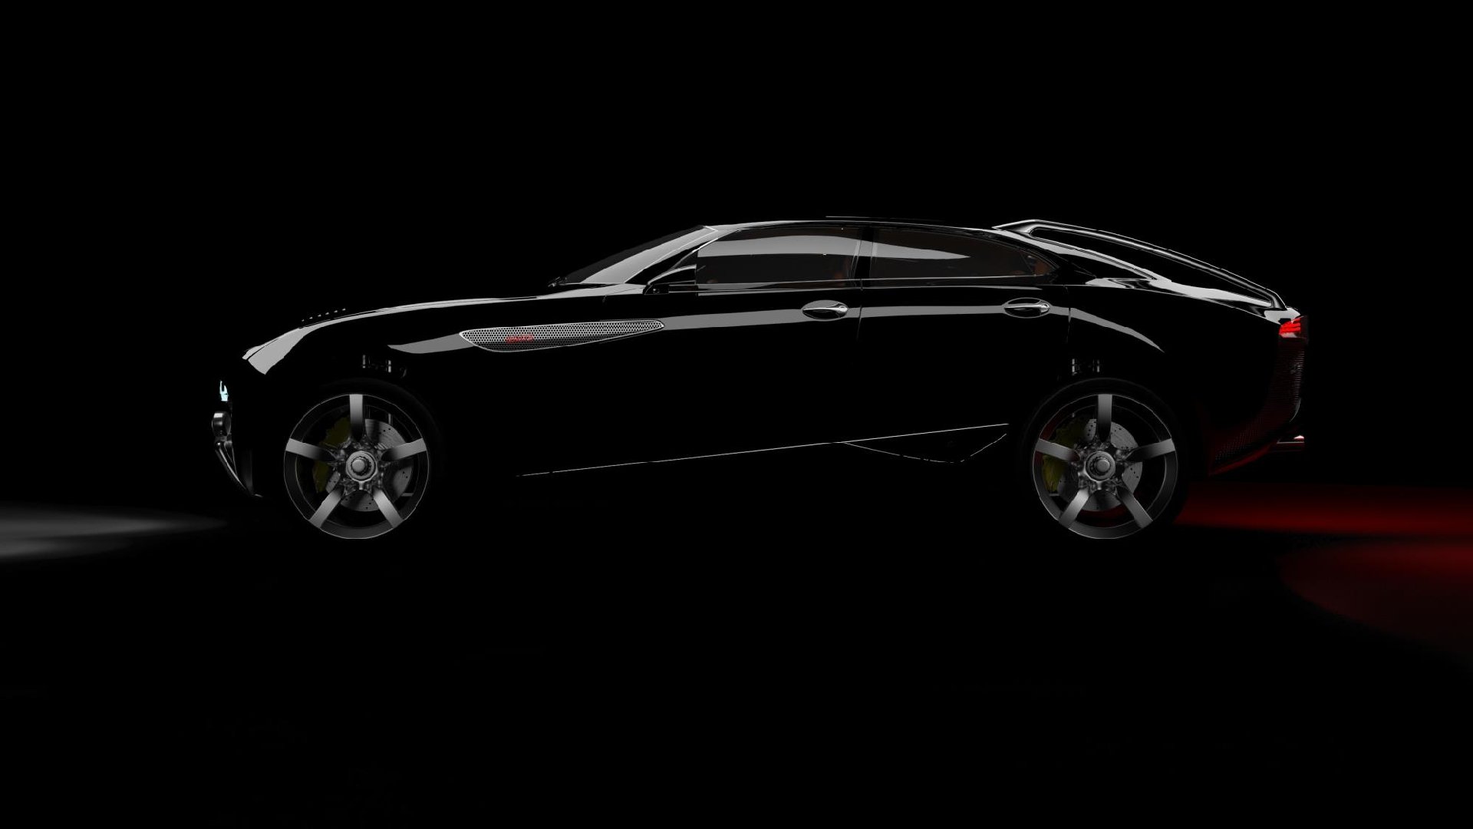

AQOS DINA

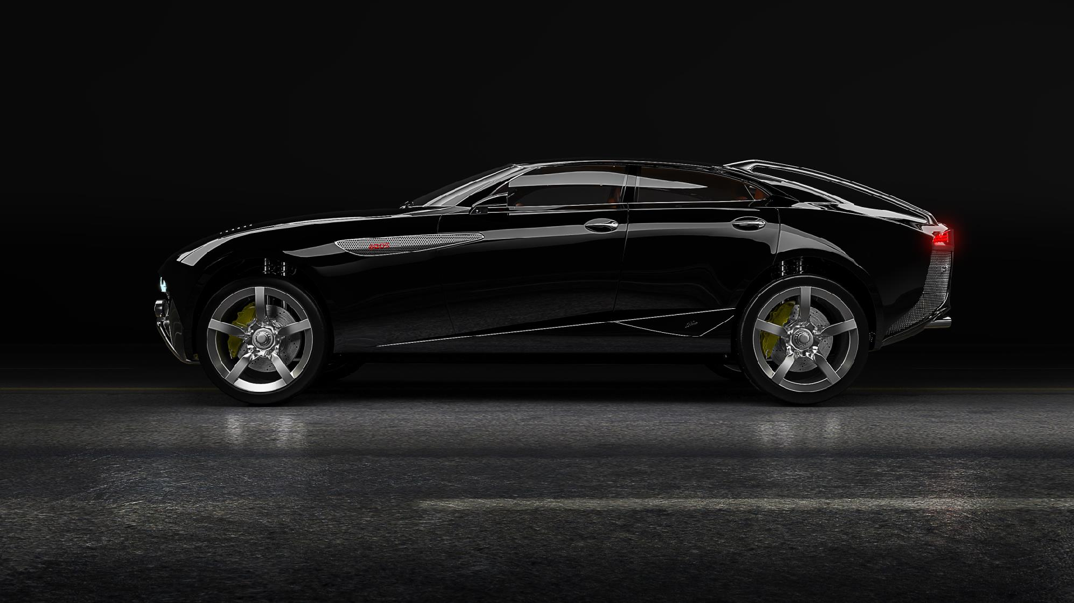

AQOS DINA

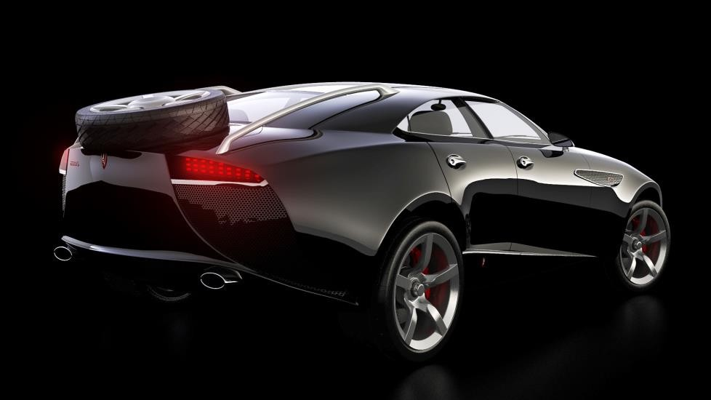
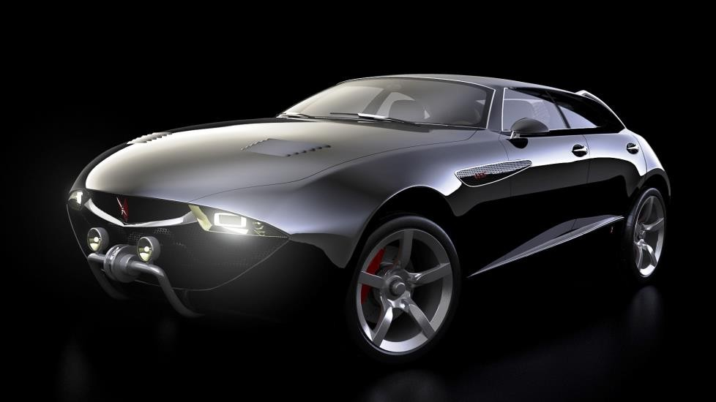

TWO MODELS IDEA 08


Aware of the potential reputation risk of the Principality of Monaco and Passion Sea in the early stages of the creation of this project, we are ready to take all risks of brand reputation and credibility to AQOS, until the project is fully completed to its final stage of execution.
Good taste (GT as a syntagma of AQOS, not Grand Tourer), as a very rare occurrence at the present level of civilization, by this project would get its platform through the construction of 2 car models in limited series of 1,000 units each.

TWO MODELS IDEA 08

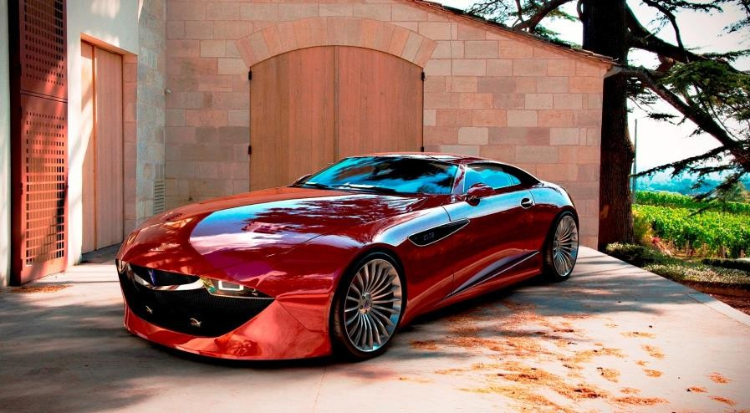
(MON)AQOS Fiore GTS – 2+2-seater configuration (with production of 700 units in coupe class and production of 300 units in convertible class)

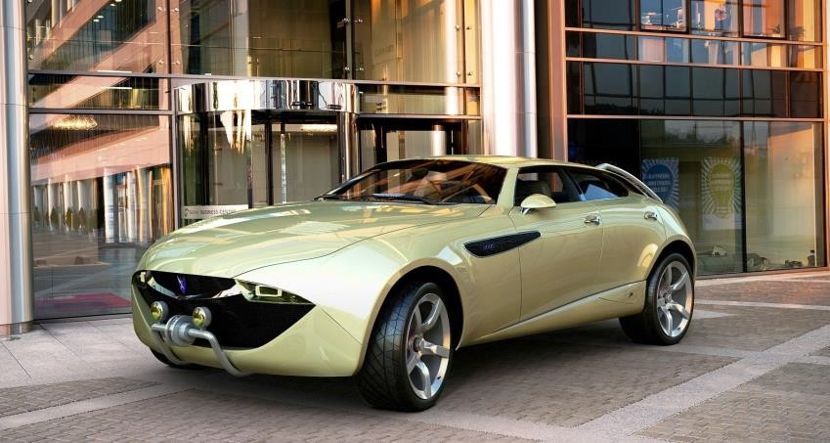

(MON)AQOS Dina – off-road 4-seater configuration

QUESTION


So, what is the initial

goal?

ANSWER

To create a car-brand that represents the character and personality of its owner, and that implies the decency (releasing the burden of social competition as a relic of spiritual immaturity and as an act of educating other people who are not at that level).

AQOS MONAQOS DNA 09
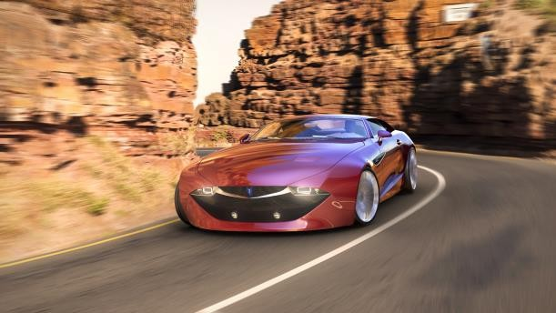
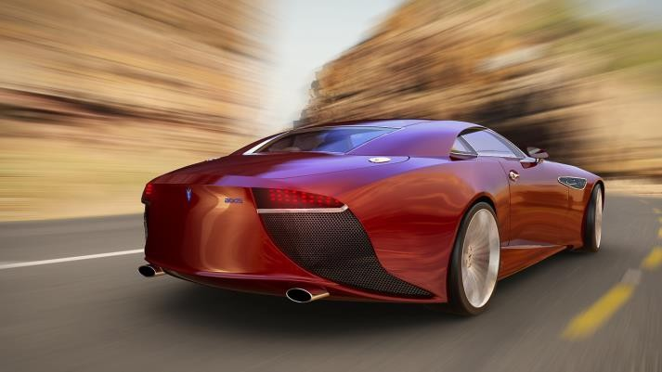
The sensation of touch, smell and ergonomics with the unquestionable technical package, defines only top connoisseurs of driving skills and style as interested in this "car industry incident", ie. the appearance on the market.

A unique, creative performance that lacks the primitivism of conventional marketing campaigns, combined with superior technical performance that requires partners who will ennoble their technical and craft superiority with a philosophical understanding of the project through their presence and involvement.

The obviousness of this text is conditioned by the DNA of this idea, without the pretension to build exclusivity by exhibitionism as a way of drawing attention to the market, but by the well-founded intention to create unquestionable value through the predestination of talent and knowledge necessary to create a project (to whom the judgement of economic effects is as important as the judgement of history - the arts).

The newly created philosophical-logical and technical-technological solutions would be easy to apply to all other branches of industrial design (architecture, yachts, accesory, fashion).

SWOT ANALYSIS 10

STRENGTHS
New vision and strategy Diversification of strong product Unique new product
Brilliant unchangeable

OPPORTUNITIES

Creating new trend in automotive business
High possible profitability and revenue

styling/designing

WEAKNESSES
New entrant in global market with
better features and design

THREATS

No brand history
No brand presence and reputation across globe
Time consuming process of building trust of investors and business partners Economic slowdown
Barriers of market entry Volatility in global car demand Increasing fuel price
Rising raw material prices
New emission standards

BENCHMARK 11
- Building of 1:1 scale concept models (show cars) needs to communicate with the potential market.
Engineering and manufacturing partner: Magna Steyr, Graz, Austria; Envisage, Coventry, England
- Presentation of the AQOS Car Project to communicate with the market and the media worldwide. Partner: Futura, EU
- Construction (R&D) of a mobile prototypes - complete vehicle engineering, validation and safety testing. Engineering and manufacturing partner: Magna Steyr, Graz, Austria
- Production organization on a contractual basis at Magna Steyr plants - complete low-volume vehicle manufacturing Manufacturing partner: Magna Steyr, Graz, Austria

*All investment and timing requirements will be defined after negotiations with potential partners

SALES AND REVENUE PROJECTION 12

Brand model
Code | Suggested Price
Fiore GTS | € 500.000
Dina | € 500.000

Car sales projection (units) | Net profit projection (€ mill)
1.000 | 250
1.000 | 250

*Note:
The tables are presented on the basis of conceptual bisiness perception and are the result of previous multidisciplinary knowledge on the basis of which we believe very strongly in the relevance of all numbers. We are ready for a follow-up analysis by licensed companies to verify all the data.

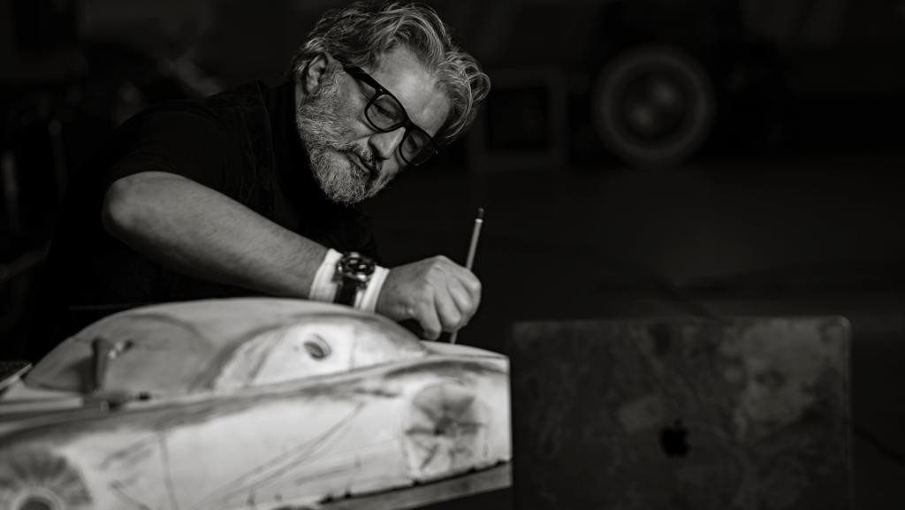

The birth of a new brand begins the moment you feel the power of dominance over a car, from which you are looking at the present moment from a historical distance, i.e., when a new logical algorithm is set that articulates all the manifesting questions related to the philosophy of car making and their technical realization. The meaning and the full effect of a new brand is only possible if the momentum is synchronized with understanding the needs of civilization. At that moment and in that case, we have the effect of the market void, which absorbs the new ideology of the new brand.

Saša Milovančević, CEO

BUSINESS OVERVIEW - CORE 13

VALUES DESIGN SUSTAINABILITY COMMUNITY
ENGAGEMENT

-Enabling consumer sustainable choices
-High-performance oriented
-Deeply rooted design heritage through backing from experience
-Differentiation through avant-garde design, driving experience and sustainable choices
-High tech minimalism that defines luxury for the sustainable age
-Designer-led leadership and product development focus
-Best-in-class sustainability ambition
-Planned introductions of sustainable materials
(e.g., natural fibers and recycled materials) throughout interiors as product portfolio matures
-Professionalized marketing approach and real time brand valuation
-Transparency

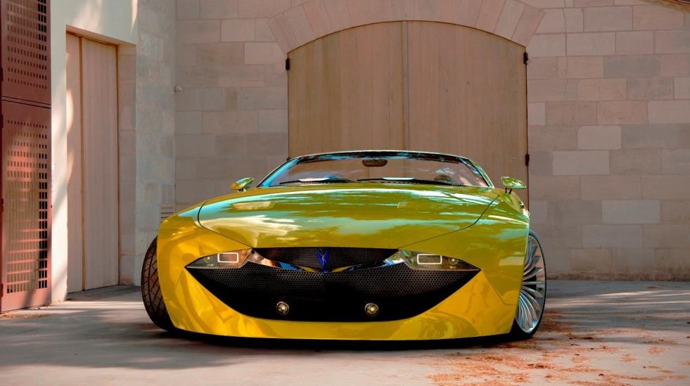
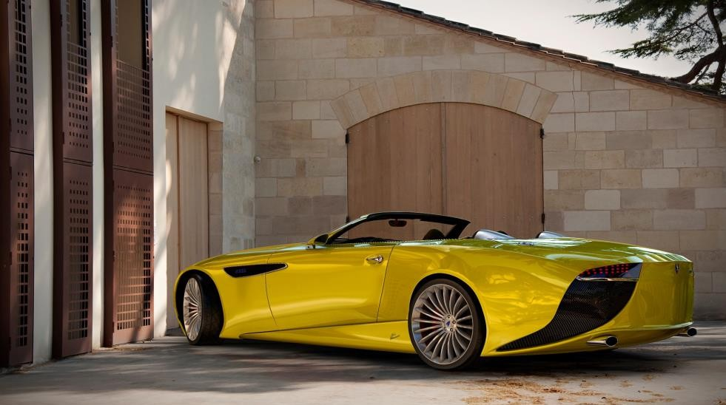
A Picture Is Worth a Thousand Words

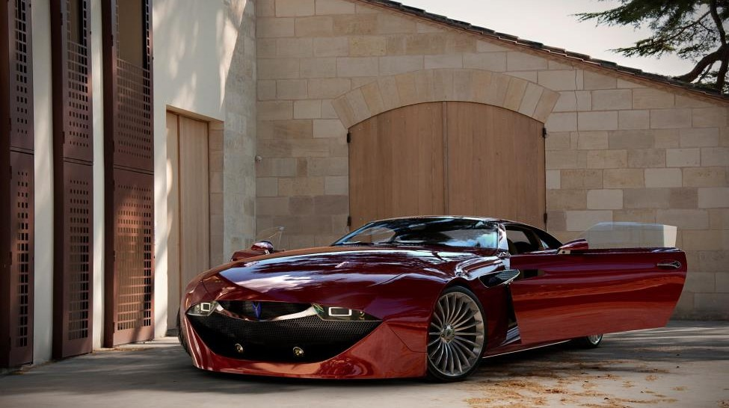
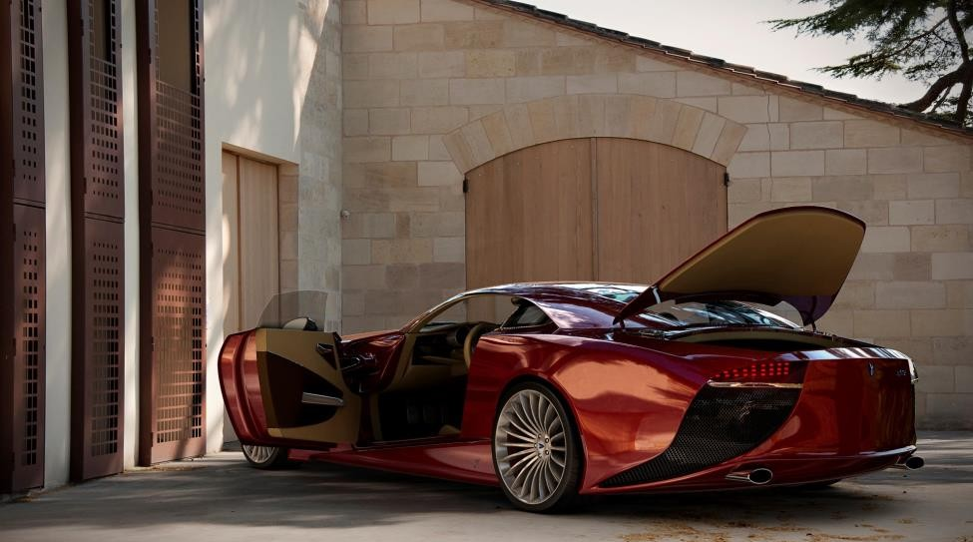
A Picture Is Worth a Thousand Words

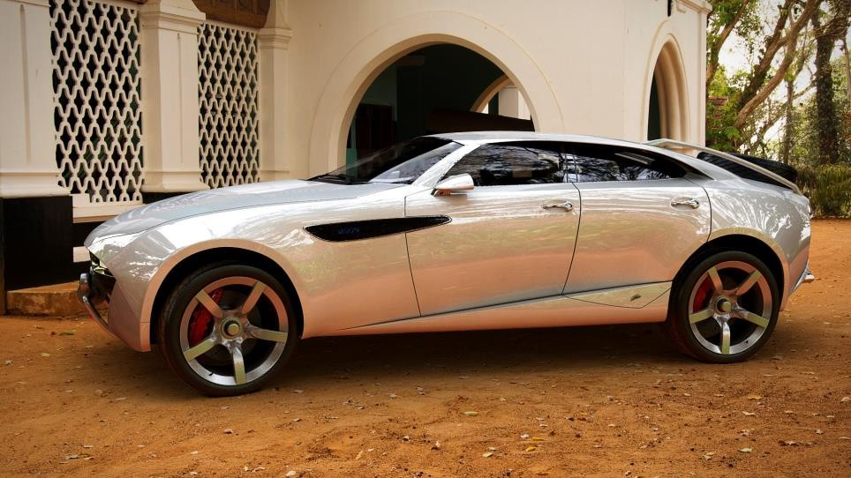
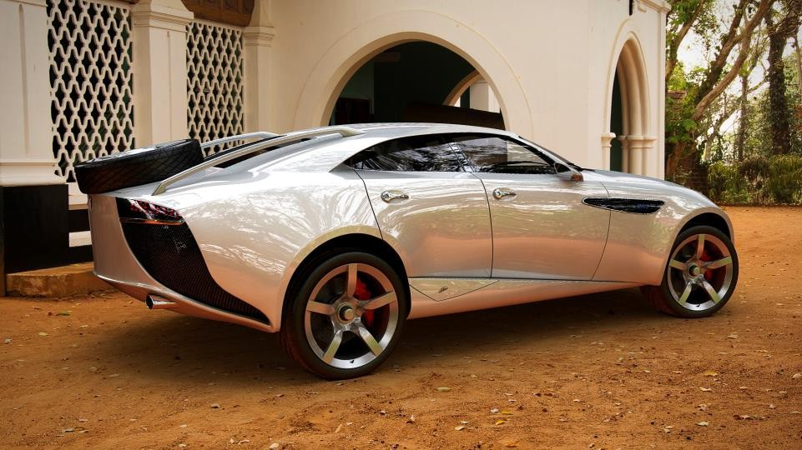

A Picture Is Worth a Thousand Words

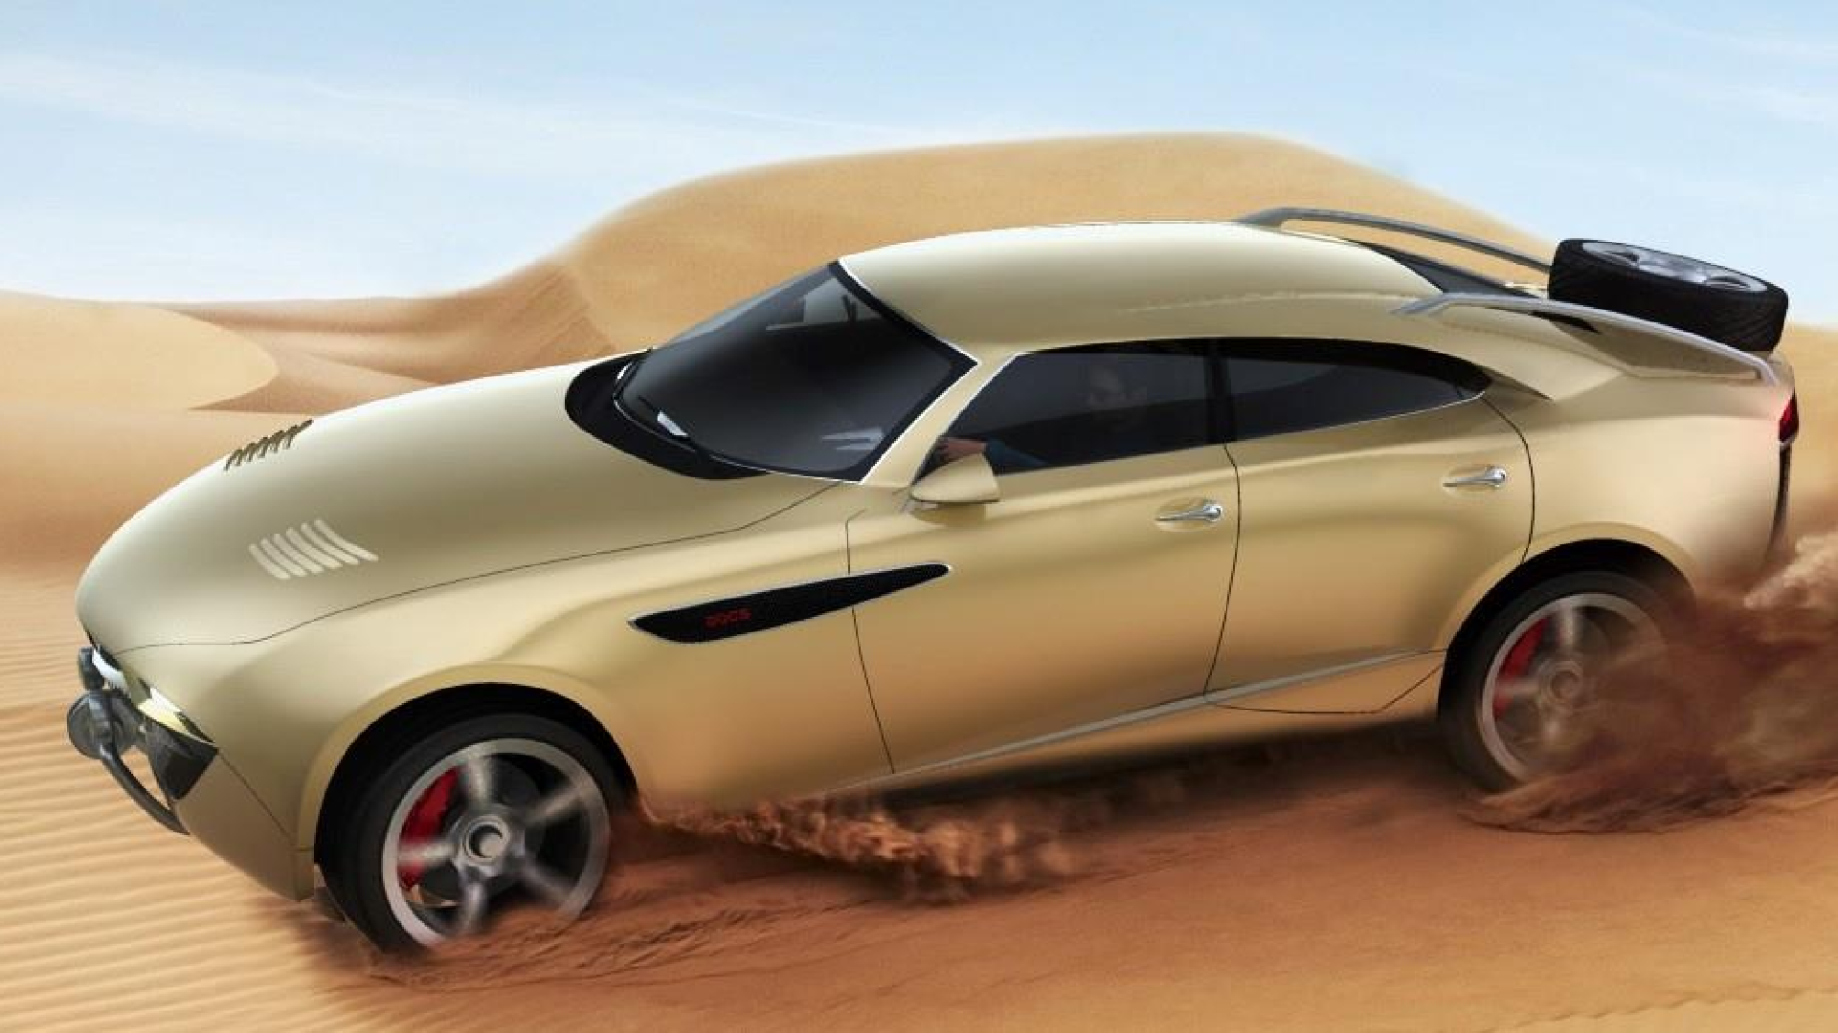

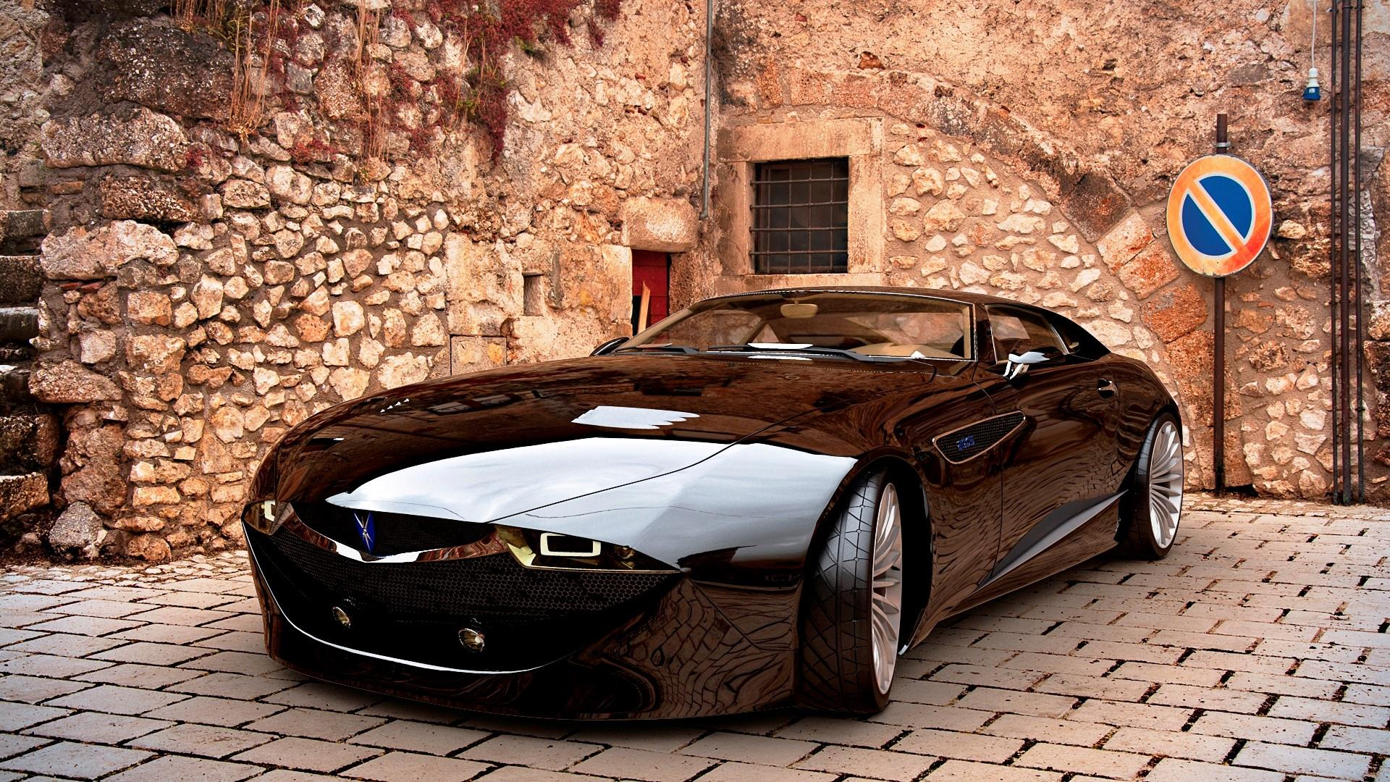

OUR TEAM

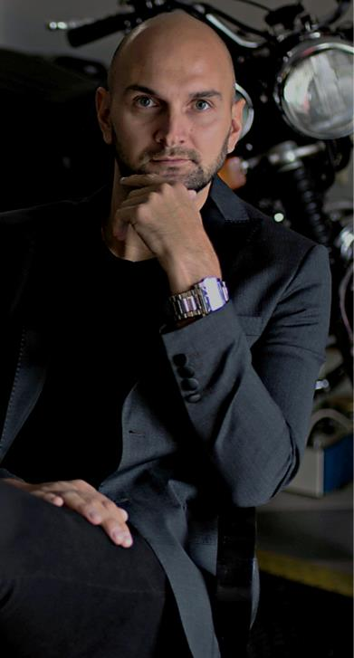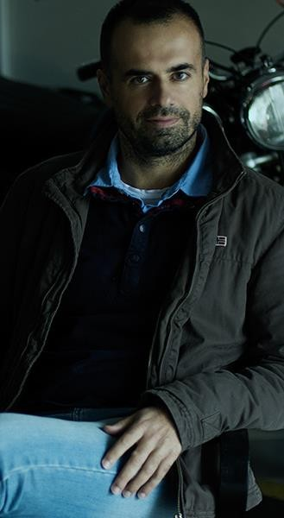

Saša Milovančević
Jenna Doe
Founder - CEO & Chief
Designer

Marko Cvetković
Marketing

dr Igor Balać
Structural Engineering

dr Nebojša Kolarić
Strategy & Organization

OUR TEAM

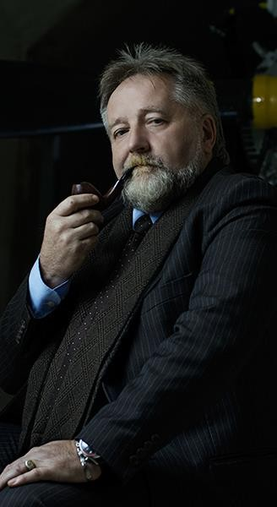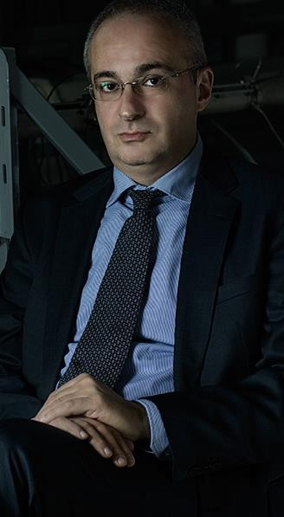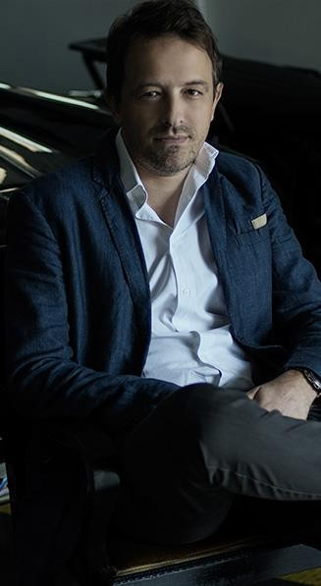

dr Časlav Mitrović
Jenna Doe
Aerodinamics

dr Petar Uskoković
Research and Advanced Engineering

Dragoljub Pavlović
Mechanical Engineering

Predrag Obradović
Product Development

OUR TEAM


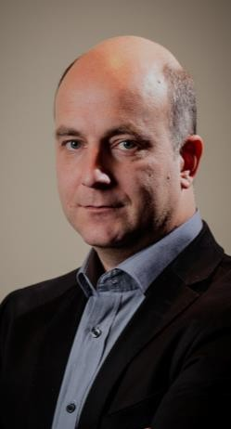
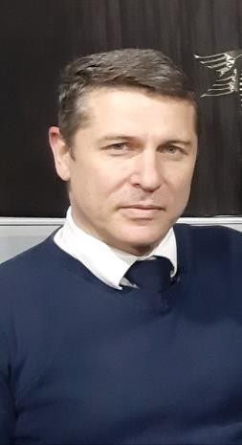
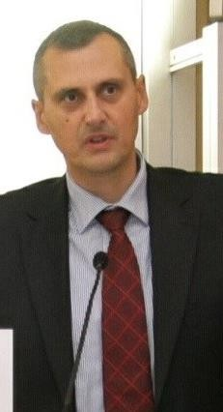


M Sc Svetlana
Maksović
Business
Operations

Čedomir
Duboka
Chief Product Officer

Prof. Dr.
Predrag Mitrović
Head of finance

Aleksandar
Djoković
Head of car software developement

Marko
Santrač
Mechanical Engineering

MONAQOS ACCESSORIES
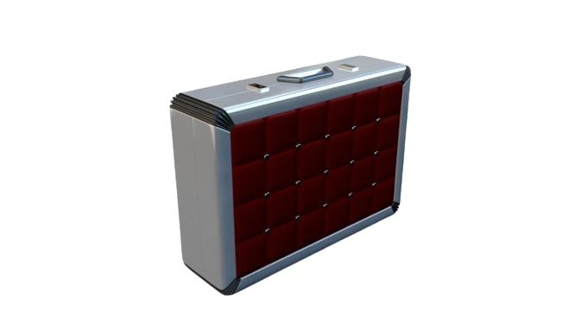
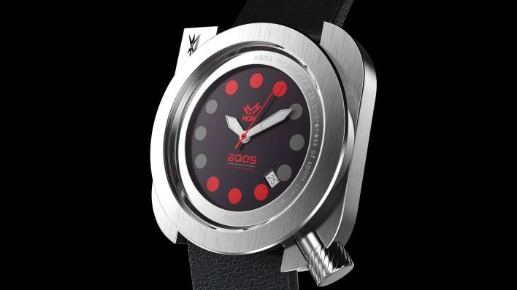
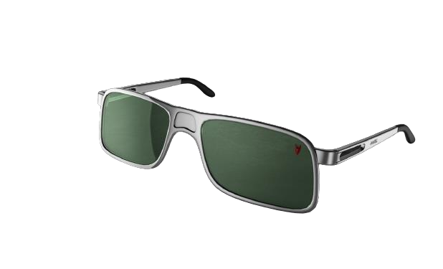
bonus preview

The object of desire called "the car" has converted the world economy to auto-centric in the last hundred years. Overproduction caused an overconfidence effect on the car manufacturers pleased with their mass production cars and therefore opened space for new brand positioning and new players.





Thank You
Aqos Technologies
Belgrade, Serbia
marko.cvetkovic@aqos.co.uk
+381607150150
www.aqos.co.uk

